Pythagoras’s theorem
Pythagoras’s theorem is ONLY applicable to RIGHT-HAND TRIANGLES.
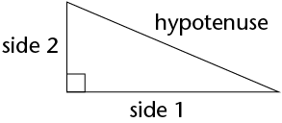
picture from siyavula. https://intl.siyavula.com/read/maths/grade-9/pythagoras-theorem/14-pythagoras-theorem,
The hypotenuse will ALWAYS be OPPOSITE the right angle and will also be the largest side on the triangle.
Pythagoras’s equation states that:
c^2 = a^2 + b^2
(hypotenuse)squared = (side 1)squared + (side 2)squared
example: calculate c, which is the hypotenuse

4cm

b
c

3cm
a

c^2 = a^2 + b^2
c^2 = (3)^2 + (4)^2
c^2 = 9 + 16
c^2 = 25
c = square root of 25
c = 5

