2.9 PHOTOSYNTHESIS
2.9.1 Photosynthesis is the production of carbon compounds in cells using light energy.
- Complex carbon compounds needed to build structure in cells and life processes.
- Photosynthesis uses light energy and simple inorganic substances, such as CO2 and water.
- Photosynthesis is an energy conversion, from light energy to chemical energy in carbon compounds, incl. carbohydrates, proteins and lipids.
2.9.2 Visible light has a range of wavelengths with violet the shortest wavelength
and red the longest.
- Light made up of all the wavelengths of electromagnetic radiation that our eyes can detect.
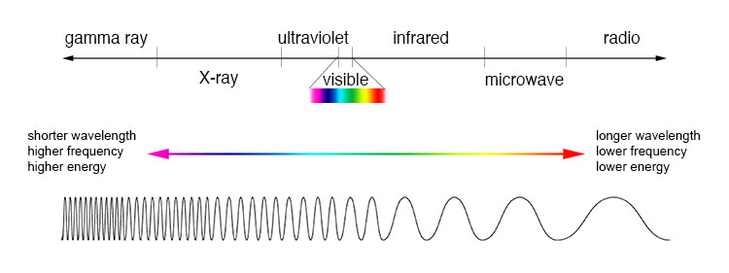
- Visible light are the only wavelengths that our human eyes can detect.
- Range of wavelengths of visible light: 400 to 700 nanometres
- Sunlight is a mixture of different wavelengths, which we see as different colours, evident in the rainbow, when droplets of water in sky split sunlight up.
- Violet- shortest wavelength, red-longest wavelength
- Wavelengths of light detected by eye are used by plants for photosynthesis because they are emitted by the sun and penetrate the Earth’s atmosphere in greatest quantities.

2.9.3 Chlorophyll absorbs red and blue light most effectively and reflects green light more than other colours.
- 1st stage of photosynthesis: absorption of sunlight, involves pigments.
- Pigments that absorb all colours of light appear black, as they emit no light. It is not white or transparent, as this doesn’t absorb light.
- There are pigments that absorb some wavelengths of visible light but not others.
- e.g. Gentian flowers contain pigment delphinidin, reflects blue light and absorbs all other wavelengths, so appear blue to us.
- Photosynthesizing organisms use range of pigments, main pigment: chlorophyll
- Chlorophyll absorbs red and blue light most effectively but the intermediate green light less effectively, so reflects green light and chlorophyll pigment appears green to us.

2.9.4 Oxygen is produced in photosynthesis from the photolysis of water.
- Photolysis (Photo=light, -lysis=disintegration), important stage of photosynthesis
- Splitting of molecules of water to release electrons needed in other stages.
- All of oxygen generated from photolysis, oxygen waste product, diffuses away

2.9.5 Energy is needed to produce carbohydrates and other carbon compounds from carbon dioxide.

carbon dioxide + water → carbohydrate + oxygen

- Energy put into reaction, so endothermic
- Reactions endothermic in most living organisms.
- Small molecules reacted to make larger molecules, e.g. carbohydrates, making of bonds, usually produces endothermic reaction.
- Energy from absorbing light

2.9.6 Temperature, light intensity and carbon dioxide concentration are possible limiting factors on the rate of photosynthesis.
Limiting Factors | Graphs | Explanation
Temp | 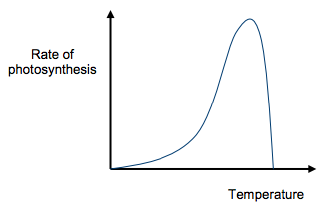 | Light dependent reactions are catalysed by enzymes, which are affected by temperature. As enzymes approach optimum temp, maximum rate of photosynthesis. Temp above optimum will make enzymes denature.
Light intensity | 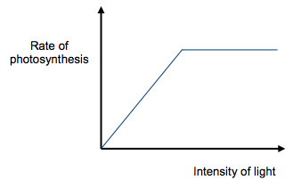 | As light increases, rate of photosynthesis increases proportionately. The more photons of light that fall on a leaf, the greater the number of chlorophyll molecules that are ionised and the more ATP and NADPH are generated. Light dependent reactions use light energy and so are not affected by changes in temperature.
CO2 | 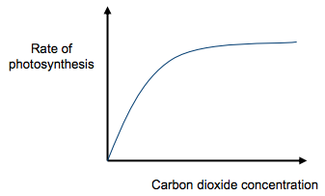 | An increase in the carbon dioxide concentration increases the rate at which carbon is incorporated into carbohydrate in the light-independent reaction, and so the rate of photosynthesis generally increases until limited by another factor.
Rate of photosynthesis:
- temp, light intensity, carbon dioxide concen
- Limiting factors: these factors can limit rate of photosynthesis if below optimal level.
- Only one factor limiting rate of photosynthesis, factor furthest from optimum
- If one factor is limited, changing other factors will have no effect on rate of photosynthesis.
- When limiting factor moved closer to optimum, while keeping other factors constant, point will be reached when factor no longer in shortest supply and other factor will become the limiting factor.
- e.g. at night, light is limiting factor but when sun rises, light increases, temp usually become limiting factor. Temp increases during morning, CO2 concen becomes limiting factor.

Shown in graph, increasing light intensity to higher levels will eventually have no effect on the rate of photosynthesis, as there will be other factors, that is CO2 or temp in short supply and will become the limiting factor.
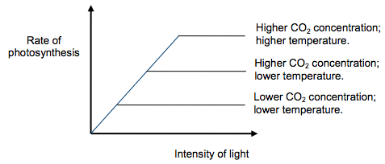

APPLICATION AND SKILLS
• Application: Changes to the Earth’s atmosphere, oceans and rock deposition
due to photosynthesis.
3500 mya- Prokaryotes first organisms to photosynthesize
later- algae and plants, photosynthesize ever since
Consequence of photosynthesis:
- rise in oxygen concen of atmosphere, Great Oxidation Event- began 2400 mya, rising to 2% by volume by 2200 mya
- first glaciation (formation of glaciers and ice sheets)- rise in oxygen concen, decrease methane concen and photosynthesis causing decrease CO2 concen, reduction in greenhouse gases, causes glaciation
- increase in O2 concen in oceans in 2400 mya ~ 2200 mya caused oxidation of dissolved iron to form precipitate on sea bed. Thus, leads to banded iron formation, layers of iron oxide alternating with other minerals
- continues 2% oxygen concen in atmosphere in 2200 mya ~ 750-635 mya, then significant rise to 20% or more. Corresponds to period when many groups of multicellular organisms evolving.

• Skill: Drawing an absorption spectrum for chlorophyll and an action
spectrum for photosynthesis.
Action spectrum: graph showing rate of photosynthesis at each wavelength of light.
Absorption spectrum: graph showing % of light absorbed at each wavelength.
Similar action and absorption spectrums- photosynthesis can only occur in wavelengths of light that chlorophyll or other photosynthetic pigments can absorb. The main difference between the two spectras is rate of photosynthesis and % light absorbed, photosynthesis dependent on % light absorbed.
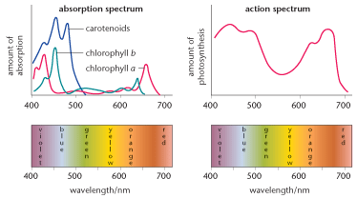

• Skill: Design of experiments to investigate the effect of limiting factors on
photosynthesis.
• Skill: Separation of photosynthetic pigments by chromatography. (Practical 4)

Nature of Science
Experimental design: controlling relevant variables in photosynthesis experiments is essential.
Independent variable- deliberately vary, range of levels you choose
Dependent variable- measure, see if affected by independent variable
Control variables- all other variables should be controlled, only independent should be affecting the dependent

In photosynthesis experiments:
Independent variable- limiting factor to investigate
Dependent variable- measure rate of photosynthesis
Control variable- keep other limiting factors at constant optimal level

