Question:
- Why Perfect Competition is better/more desirable than Monopoly
- Differences between Perfect Competition and Monopoly
- Using Diagram, explain why monopolistic competition is neither allocative nor productive efficient
- Using diagrams, compare and contrast the market structure of monopoly with that of perfect competition
- Explain whether price will always be lower and out will always be higher in perfect competition compared to monopoly.

Perfect Competition:
- In a perfectly competitive market, there are many producers and consumers, no barriers to enter and exit the market, perfectly homogeneous goods, perfect information, and well-defined property rights.
- This produces a system in which no individual economic actor can affect the price of a good – in other words, producers are price takers that can choose how much to produce, but not the price at which they can sell their output.
- Example: Commodity markets (such as coal or copper) typically have many buyers and multiple sellers. There are few differences in quality between providers so goods can be easily substituted, and the goods are simple enough that both buyers and sellers have full information about the transaction. It is unlikely that a copper producer could raise their prices above the market rate and still find a buyer for their product, so sellers are price takers.
Monopoly:
- There is only one producer and many consumers. Monopolies are characterized by a lack of economic competition to produce the good or service and a lack of viable substitute goods (BAD). Consumers have no choice in terms of goods selection unlike in perfect competition.
- As the single producer has control over the price of a good – in other words, the producer is a price setter that can determine the price level by deciding what quantity of a good to produce (BAD). Consumers have no influence over price.
- Example: Public utility companies tend to be monopolies. In the case of electricity distribution, for example, the cost to put up power lines is so high it is inefficient to have more than one provider. There are no good substitutes for electricity delivery, so consumers have few options. If the electricity distributor decided to raise their prices it is likely that most consumers would continue to purchase electricity, so the seller is a price maker.
Similarities:
- Both face the same cost and production functions, and both seek to maximize profit. The shutdown decisions are the same, and both are assumed to have perfectly competitive factors markets.
- Both seek Profit Maximisation where (MC = MR). The marginal cost curves faced by monopolies are similar to those faced by perfectly competitive firms. Most will have low marginal costs at low levels of production, reflecting the fact that firms can take advantage of efficiency opportunities as they begin to grow. Marginal costs get higher as output increases.
Differences:
- Under perfect competition, there exist no restrictions on the entry or exit of firms into the industry. Under simple monopoly, there are strong barriers on the entry and exit of firms.
- Under simple monopoly, a monopolist can charge different prices from the different groups of buyers. But, in the perfectly competitive market, it is absent by definition.
- The difference between price and marginal cost under monopoly results in super-normal profits to the monopolist. Under perfect competition, a firm in the long run enjoys only normal profits
- Under perfect competition equilibrium is possible only when MR = MC and MC cuts the MR curve from below. But under simple monopoly, equilibrium can be realized whether marginal cost is rising, constant or falling
- In a perfectly competitive market, price equals marginal cost and firms earn an economic profit of zero. In a monopoly, the price is set above marginal cost and the firm earns a positive economic profit.
- Perfect competition produces an equilibrium in which the price and quantity of a good is economically efficient. Monopolies produce an equilibrium at which the price of a good is higher, and the quantity lower, than is economically efficient (BAD). Productive inefficiency as production is made at a level which is less than minimum average cost due to less quantity produced and charge a higher price. For this reason, governments often seek to regulate monopolies and encourage increased competition.
- Monopoly is also allocative inefficient as it does not supply enough output (socially optimum level not achieved P = MC) (BAD). When P > MC the marginal benefit to society as measured by P = AR) is greater than the marginal social cost to society of producing additional units, and a greater quantity should be produced. But monopoly produces at MC=MR.

- For monopolies, marginal cost curves are upward sloping and marginal revenues are downward sloping.
- For Profit maximization, Perfect Competition (MC = MR = AR). For monopoly, MC = MR but, not equal to AR. Monopoly, being the only firm will set a price higher than perfect competition, where output is lower than perfect competition.
- Draw the Monopoly Diagram and state these 5 points:

  - First, marginal revenue lies below the demand curve. This occurs because marginal revenue is the demand, p(q), plus a negative number.
  - Second, the monopoly quantity equates marginal revenue and marginal cost, but the monopoly price is higher than the marginal cost.
  - Third, there is a deadweight loss, for the same reason that taxes create a deadweight loss: The higher price of the monopoly prevents some units from being traded that are valued more highly than they cost.
  - Fourth, the monopoly profits from the increase in price, and the monopoly profit is illustrated.
  - Fifth, since—under competitive conditions—supply equals marginal cost, the intersection of marginal cost and demand corresponds to the competitive outcome.
  - =====) To maximize output, monopolies produce the quantity at which marginal supply is equal to marginal cost.

- Monopolies can influence a good’s price by changing output levels, which allows them to make an economic profit
- Because a monopoly’s marginal revenue is always below the demand curve, the price will always be above the marginal cost at equilibrium, providing the firm with an economic profit.

Distinguish between decreasing returns to scale and the law of diminishing returns. (10 marks)
Return to Scale:
In the long run, all factors of production are variable. How the output of a business responds to a change in factor inputs is called returns to scale. Explain 3 types of return to scale”
- Increasing returns to scale occur when the % change in output > % change in inputs
- Decreasing returns to scale occur when the % change in output < % change in inputs
- Constant returns to scale occur when the % change in output = % change in inputs
The nature of the returns to scale affects the shape of a business’s average cost curve – when there are sizeable increasing returns to scale, and then we expect to see economies of scale from long run expansion.
• Decreasing returns to scale happens on the upward sloping part of the long-run average total cost (LRATC) curve. This is when a company is "too big for its own good." If the company is very-very large it might have higher costs per unit if it further increases output e.g. due to problems of communication or being regulated by the government.
• In such cases many large firms decide to spin off some areas of business (split off sections as separate companies). A proper definition of decreasing returns to scale is that an increase in the quantity of inputs (land and/or labour and/or capital) will produce a proportionally smaller increase in the quantity of output. Since all of the factors of production are variable, this happens in the long-run.

Finding an optimal mix between labour and capital
- In the long run businesses will be looking for an output that combines labour and capital in a way that maximises productivity and reduces unit costs towards their lowest level.
- This may involve a process of capital-labour substitution where capital machinery and new technology replaces some of the labour input.
- In many industries over the years we have seen a rise in the capital intensity of production - good examples include farming, banking and retailing.
- Robotic technology is extensively used in many manufacturing / assembly industries such as cars. The image on the left is of a Ford car assembly factory in India.
- Robotics does not always replace labour! For example, the car manufacturer Toyota has introduced over 100 manual-intensive workspaces across its factories so that younger workers can understand

LAW OF DEMINISHING RETURN:
Definition: Law of diminishing marginal returns
The law of diminishing returns states that as firms grow, adding additional units of variable resources (usually labour) to fixed resources (land, capital), there is going to be a point over which the productivity of these additional variable inputs decrease.
- At a certain point, employing an additional factor of production causes a relatively smaller increase in output.
- Diminishing returns occur in the short run when one factor is fixed (e.g. capital)
- If the variable factor of production is increased (e.g. labour), there comes a point where it will become less productive and therefore there will eventually be a decreasing marginal and then average product.
- This is because, if capital is fixed, extra workers will eventually get in each other’s way as they attempt to increase production. E.g. think about the effectiveness of extra workers in a small café. If more workers are employed, production could increase but more and more slowly.
- This law only applies in the short run because, in the long run, all factors are variable.

- In plain English, if you have a set number of machines and you are hiring more and more people, at first with each additional worker your output will grow proportionally more, but after a while the productivity of each additional employee will start to decrease it (e.g. workers are in the way of each other, or machines are working at or close to full capacity). Since only labour is a variable resource, whereas land and capital are fixed, this happens in the short-run (as opposed to the decreasing returns to scale phenomenon).
Examples:
- Use of chemical fertilisers. A good example of diminishing returns includes the use of chemical fertilisers- a small quantity leads to a big increase in output. However, increasing its use further may lead to declining Marginal Product (MP) as the efficacy of the chemical declines.
- Revising into early hours of the morning. If you revise economics for six hours a day, you will improve your knowledge quite a bit. However, if you continue to revise into the early hours of the morning, the amount that you learn increases by only a small amount because you are tired.
- Employing extra workers. A cafe may wish to serve more customers during the busy summer months. However, employing extra workers may be difficult because of a lack of space in the cafe.
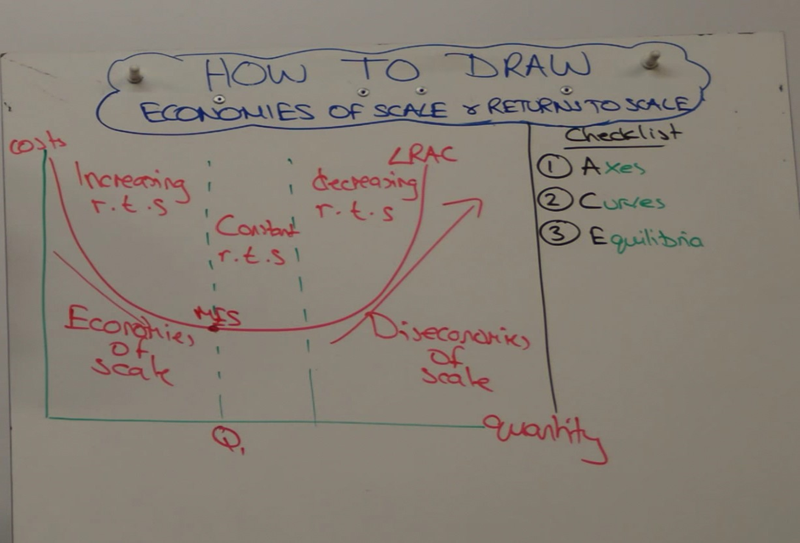
Explain why some firms might choose the goal of profit maximization while others might choose to adopt satisficing behaviour?
Profit Maximisation is a method of setting prices that occurs when marginal revenue equals marginal cost. It is assumed that the goal of the private firm will choose that level of output for which economic profits are maximum, which requires that marginal revenue (MR) is equal to marginal cost (MC) and that MC is rising.
It is generally assumed that private firms are profit maximisers; seeking to produce at the level of output that generates the highest level of profits. This occur at the level of output where marginal cost equals marginal revenue (i.e. MC= MR):
- If MR > MC, firms increase their output because profits will rise.
- If MC > MR, firms reduce their output as the marginal cost outweighs the marginal revenue. Therefore, profits are maximised when MC = MR.
(Draw Diagram) and explain.

On the other hand, Satisficing is about a firm choosing an option that is acceptable, although not necessarily the best or perfect. This is because profit maximisation might require significant expenditure of time, effort and financial resources. As an alternative to profit maximazation, satisficing is adopted because of conflicting objectives of the various stakeholders within a firm and informational limitations. Therefore, firms only strive to achieve at least some pre-defined minimum level of profits or revenues such as revenue maximisation, growth maximisation, and corporate social responsibility.
For example, a large modern enterprise cannot be looked upon as a single entity with a single maximising objective; instead it is composed of many separate groups within the firm, each with its own objectives which may overlap or may conflict. This <multiplicity> of objectives does not allow the firm to pursue any kind of maximising behaviour. Firms therefore try to establish processes through which they can make compromises and reconcile conflicts to arrive at agreements, the result of which is the pursuit of many objectives that are placed in a hierarchy. This behaviour was termed satisficing, referring to the idea that firms try to achieve satisfactory rather than optimal or 'best' results. Satisficing behaviour is an alternative business objective to maximising profits. It means a business is making enough profit to keep shareholders happy or it's sufficient for investors to maintain confidence in the management they appoint.

