IB Biology Notes:

Topic 1: Cell Biology

Topic 1.1 Introduction to Cells

Made by Brian Chia

Topic 1.1: Introduction to cells

Cell theory:
- Consists of 3 main points:

1. Cells are the smallest units of life
• They are the smallest structures capable of living on their own

2. All living organisms are composed of cells
• Multicellular organisms are made up of many cells, while unicellular organisms are composed of only one cell

3. New cells are formed by pre-existing cells
• New cells arise through cell division

Exceptions to the cell theory:
- There are some exceptions which are organisms and tissues that are not made up of typical cells

1. Striated muscle cells are made up contractile filaments. They are multinucleate, meaning they contain many nuclei within a cell.

2. Giant algae are unicellular organisms that can grow up to 1cm. A cell of this size would be expected to be an organism composed of many cells, but they only contain one nucleus.

3. Aseptate fungi are one long continuous cell that is not divided into sub-units, and therefore have many nuclei within this single cell.

Functions of life in unicellular organisms:
- MR. H. NERG

1. Metabolism:
• Chemical reactions inside the cells, including cell respiration to produce ATP

2. Reproduction:
• Producing offspring either sexually or asexually

3. Homeostasis:
• Maintaining an stable internal environment within the cell

4. Nutrition:
• Obtaining food, to provide energy and materials needed for growth

5. Excretion:
• Getting rid of waste products of metabolism

6. Response:
• The ability to react to changes in the environment

7. Growth:
• Increase in the size and mass of the cell

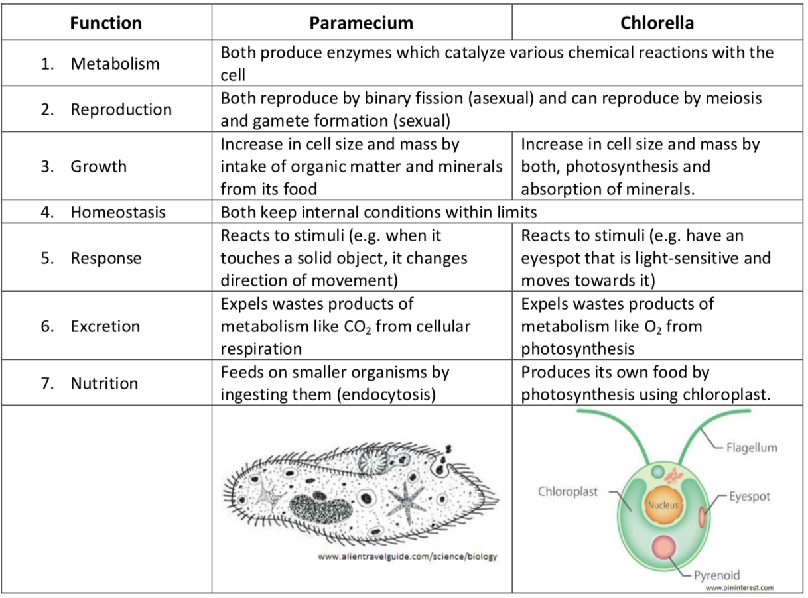
Comparison of life functions in Paramecium and Chlorella:

Multicellular organisms and cell differentiation:
- When cells are grouped together, they exhibit emergent properties as a result of their interactions between cellular components
  - Allows complex systems to function properly
  - Eg. Different cells in the retina of the eye can respond to light giving us vision and light perception. However, the combination of various cells allow us to respond to different objects within our surroundings.
- In multicellular organisms, specialized cells can develop by cell differentiation
  - Differentiation is the process where a less specialized cells develops to become more specialized.
  - Expression of various genes in the cells cause it to differentiate

Stem cells:
- Stem cells are characterized by their ability to divide via mitotic cell division and differentiate along different pathways to become a diverse range of specialized cell types
- Stem cells have 2 key properties:
  - Self-renewal: Can divide to produce copious quantities of new stem cells
  - Potency: Can differentiate in different ways to produce different cell types
- Stem cells can come from 3 sources:
  - Adult stem cells which are found in the bone marrow
  - Embryonic stem cells that are found in the inner mass of blastocysts
  - Umbilical cord blood of newly born fetuses

Applications of stem cell therapy:
- Stargardt’s disease:
  - Genetic mutation which causes progression vision loss until blindness
  - Embryonic stem cells injected into the retina can develop into retina cells, improving an individual’s vision with no side effects.
- Leukemia:
  - A type of cancer that overproduces WBCs in the bone marrow.
  - First, stem cells will be extracted from the bone marrow. Chemotherapy will then be done, killing the cancerous cells but also healthy cells.
  - After this, the stem cells will be injected back into the patient, where the stem cells can re-establish themselves in the bone marrow and multiply to produce new healthy RBCs and WBCs.

Ethics of stem cell therapy:
- Various arguments and counterarguments for the use of stem cell therapy

For stem cell therapy | Against stem cell therapy
Health and quality of life for patients suffering from possible incurable diseases can be greatly improved | Involves the creation and death of an embryo that has not differentiated
Early-stage embryos lack a nervous system, and hence are unable to feel pain during stem cell procedures | Therapeutic cloning involves human eggs, through an invasive procedure called IVF
Since embryos are produced deliberately, then no individual who otherwise would have lived has been denied its chance of living | Possible health risks in treating women with hormones in order to induce hyper ovulation to provide eggs for stem cell research
Adult stem cells are fully compatible with adult’s tissue, and have no chance of tumor formation | Embryonic stem cells have a higher chance of becoming tumor cells

SA: Vol ratio:
- It is necessary for cells to exchange substances with their surroundings
  - Eg. food, gases, and waste material
  - This is dependent on the cell’s SA
- As the size of the cell increases, its volume increases much faster compared to the SA
  - Rate of metabolism is mass/volume
- This means that as the size of the cell increases, its SA:Vol ratio will fall, and thus the cell will become less efficient at exchanging materials
- Also causes the risk of the cell overheating if more heat is produced than removed in the cell
- Thus, cells are limited to a small size and small sizes have a higher SA:Vol ratio

Magnification:
- Magnification: Image size/Actual size
  - Size of image is how large the specimen appears in the drawing (cm or mm)
  - Actual size is means how big the specimen actually is (um or nm)
    - Note: 1mm=1,000 um, 1um=1,000 nm

