IB Biology Notes:

Topic 1: Cell Biology

Topic 1.4 Membrane Transport

Made by Brian Chia

Topic 1.4: Membrane transport

Diffusion:
- Defined as the passive movement of particles from an area of high concentration to an area of low concentration
- Passive means there is no expenditure of ATP
- Diffusion is split into simple and facilitated diffusion

Simple diffusion:
- Movement of particles down the concentration gradient
- Simple diffusion across membranes occur when the substance moves through the phospholipid bilayer.
  - Substance must be small, non-charged, permeable to the membrane

Facilitated diffusion:
- Defined as the movement of particles from an area of high to low concentration with the help of channel proteins
- Occurs when specific ions or charged particles cannot pass through the phospholipid bilayer
- Protein channels are very specific, as they only allow for one type of molecule to go through their channel
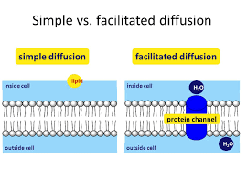
  - Eg. Na+ ions pass through a channel specific to Na ions

Osmosis:
- Defined as the movement of water molecules across a semi-permeable membrane, from a region of low solute concentration to high solute concentration
  - ie. From high water concentration to low water concentration
- Can happen in all cells because water is small enough to pass through the phospholipid bilayer
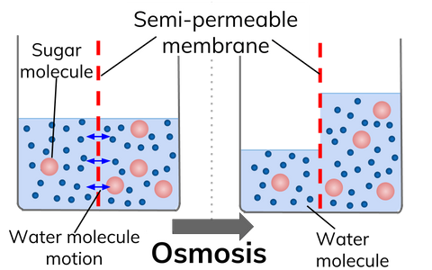

Active transport:
- Movement of molecules across the membrane using ATP
- Moves substances from an area of low concentration to high concentration (against the concentration gradient)
- Pumps work in a specific direction where substances only enter one side and exit through the other
- Each pump only absorbs a particular substance, so that cells can control what is being absorbed and expelled
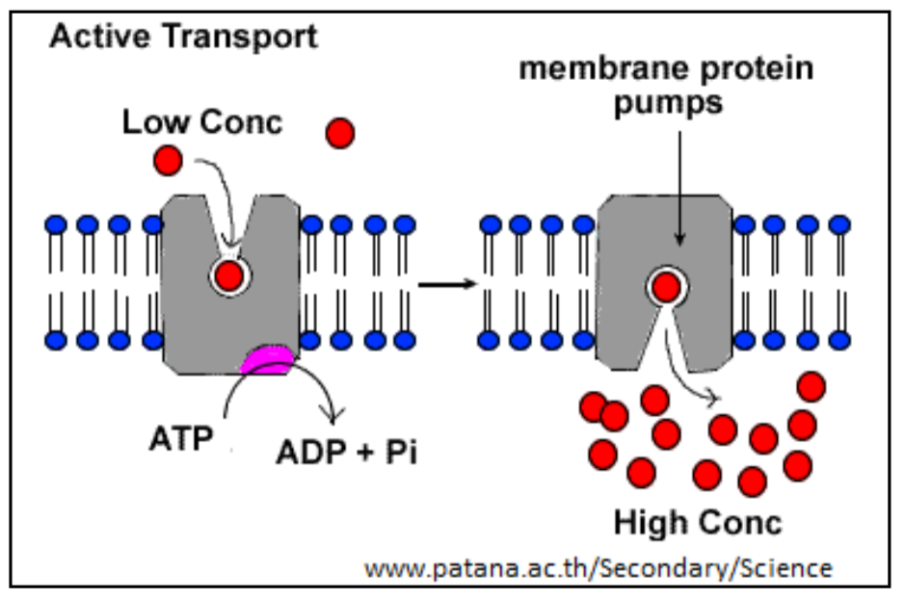
- Energy from the ATP is used to change the conformation of the protein pump

Transport using vesicles:
- Fluidity of membrane allows for materials to be taken in and out of the cell through vesicles

Endocytosis:
- External material is engulfed and enclosed by the plasma membrane
- A small portion of the plasma membrane is pinched off and becomes a vesicle with its extracellular contents within it
- These vesicles then move into the cytoplasm
- The plasma membrane then reattaches at the ends due to the fluidity of the membrane

Exocytosis:
- A vesicle created by the RER enters Golgi apparatus, where its contents are modified
- Vesicle migrates to the plasma membrane and fuses with the membrane
- It then releases the protein outside of the cell
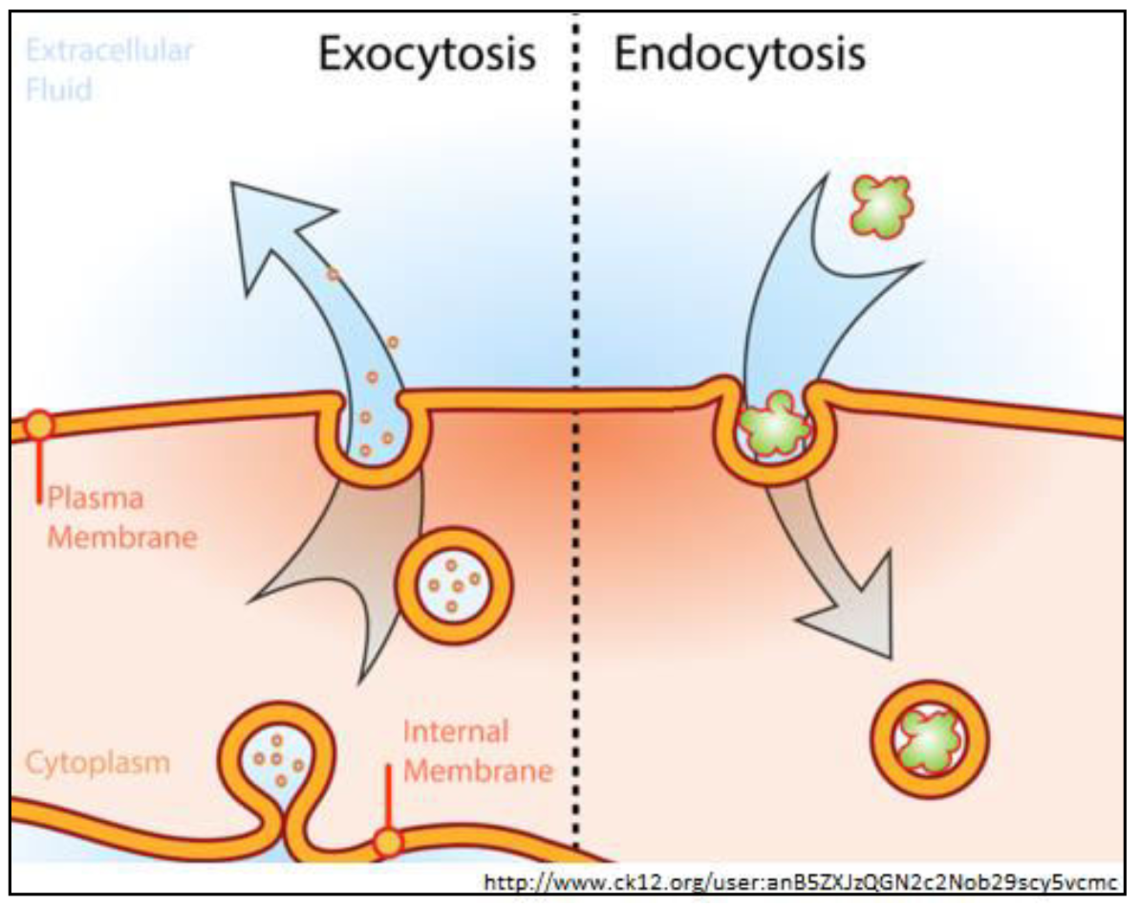
- The amphipathic properties of phospholipids, along with the fluidity of the membrane, allow for the vesicle to combine with the plasma membrane to form a new membrane that includes the phospholipids from the vesicle

