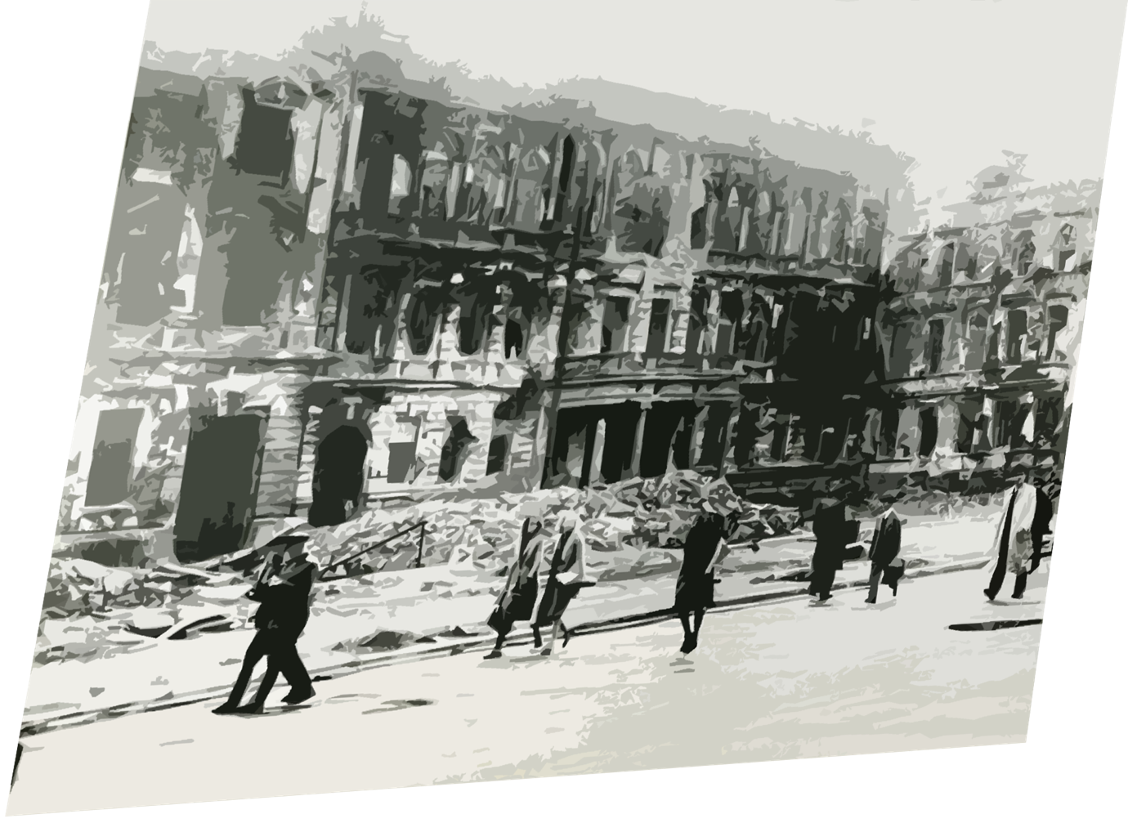

Study Guide #1 for
( Projekt 1065 )
.

The purchase of this study guide entitles the individual teacher to reproduce copies of the student pages for use in his or her classroom exclusively. The reproduction of any part of the work for an entire school or school system or for commercial use is prohibited.

Copyright@2023 Anthony Sneed

In this study guide we will use various exercises to look at different elements of the book, Projekt 1065. We will proceed through the chapters from the beginning with different exercise formats that most students are probably already familiar with:

Review of key points, multiple choice
Comprehension Short-answer questions
Vocabulary matching
Message and themes Essay
Story Map we will use evry few chapters to add information so we can look at how the story is developing.
We will not do all exercises for every chapter, and after the first 5 chapters, we will combine chapters as Projekt 1065 has many, very short chapters.

You will likely have already learned in your school classes that there are basic elements to most works of fiction.
Generaly, they are: setting, characters, plot, conflict, resolution, and theme. There are other elements such as point of view, and we will look at those as well. This study giude will try to focus on these basic elements but also touch on some of the literary devices the author uses such as metaphor, simile etc.

The objective of this guide is to help you understand what the story is about, and how the author tells the story. But equally important , this guide is meant to help you enjoy reading more through a greater understanding of the basic slements of fiction and an appreciation of the writing. Take your time with Projekt 1065 and the study guide. You may want to read several chapters at a time before doing the exercises, or do the the study guide as you finish the chapters. It is your choice. Have fun.

Attention: We have numbered the chapters although you will see that the author does not use chapter numbers in Projekt 1065. Numbering helps reference chapters easily, but you can ignore them if you wish. Here are the chapters numbered as a guide:

This study guide is based on the book Project 1065
Copyright @ 2016 Gratz, Alan. Scholastic Inc.. Kindle Edition.

1. Dinner with Nazis  2. Kristallnacht  3. My Struggle  4. Nowhere to Run  5. The Mission  6. The German Look  7 . Hitler Youth  8. Her Professor Doktor  9. Nazi Math  10. Degnerate Filth  11. Three Cheeses Tall  12. The Fighting Irish  13. How to Take a Beating  14. In Case You Forgot  15. A Pilot in a Haystack  16. Acrophobia  17. In Which I Am a Bleeding Genius  18. An Angry badger  19. The Befriending Barn  20. Exposed  21. A Small Problem  22. Our Submarine  23. Wake-Up Call  24. Projekt 1065  25. A Job to Do  26. The German Blitz  27. Oh, Crap  28. A Scream of Swifts  29. The Edelweiss Pirates  30. A Real Nazi | 31. Seat Meat  32. Culture Destroyers  33. For the Führer  34. A locked Room Mystery  35. SS-Obersturmführer Trumbauer  36. Admittance Denied  37. The Nazis Second Favorite Sport  38. An Easy Fight  39. Monsters  40. The Wrong Thing  41. Nutty as a Fruitcake  42. ArscheBombe  43. Taking the Plunge  44. Blood and Honor  45. Tears  46. Fritz’s Secret  47. Kim’s Game  48. Surrender or Die  49. Quex  50. Kuddelmuddel  51. The Wolf Pack  52. One Day  53. The Old Relic  54. A Wee Iron Coffin  55. One Last Time  56. Lucky Mushroom  57. Having Babies for Hitler  58. The Game  59. X Marks the Spot  60. Time to Kill

61. Head Cinema  62. Pirates of the Edelweiss  63. Gone  64. Operation Paperclip  65. The Missing Wine  66. An Opening on the Team  67. The Man from Nantucket  68. Evil Leprechaun  69. Hitler  70. Super Nazis  71. No Joke  72. A Walking A-Bomb  73. Boy-Men  74. All In  75. How to Take a Beating Part 2  76. Tonight  77. Owls in the Night  78. Knowing What’s to Come  79. Anything and Everythng  80. 8,422 Feet  81. The Waiting Snake  82. A Thorough Security Check  83. The Science Experiment  84. Coming Clean  85. A Silly Prank  86. Professor Hendrik Goldsmit  87. Dreams of Medals  88. Mad as Hell  89. For the Glory of Old Ireland  90. Don’t Look Down | 91. Might Makes Right  92. The New Michael  93. Shunk  94. It Didn’t  95. Thoom  96. Avalanche!  97. Untouched by War  98. An Englishman, a Scotsman, and an Irishman

Chapter 1 Dinner With Nazis

Story Element: Setting
One of the basic elements of a story is the setting. The setting is the time and place that the story occurs. Projekt 1065 is set in a very specific time and place in modern history, World War 2 Europe, and most of the story is based on actual events.

Although almost all of the characters in the story are fictional, some of the names mentioned are historical figures. We will add information on the war and some of the events mentioned as we go through the story.

In this first chapter of our study guide, the exercises focus on the setting. The narrator of the story tells you where he lives, what year it is, and where he is from originally. He even lets you know what he thinks of the people he is dining with in the first chapter. Can you also understand his feelings about the people that he is dining with and speaking about? Look at the final sentence of the first chapter!

Write down the final sentence of the first chapter and then make a few comments about how the narrator feels about the Nazis.

True/False Questions

1. Michael pretends to like the Nazis, but he really hates them.
Answer #1. (circle the answer) True False

2. The Nazi political party persecuted Jewish people and other groups who they considered “enemies”.
Answer #2. (circle the answer) True False

3. Michael’s father, Da, is the Irish Ambassador to Germany.
Answer #3. (circle the answer) True False

4. Michael and his family live in Munich, Germany.
Answer #4. (circle the answer) True False

5. Michael can not speak German.
Answer #5. (circle the answer) True False

Multiple Choice

1. The person who is telling the story is Michael. What is his last name?

a. Jordan
b. O’ Halloran
c. O’Shaunessey
d. Hitler
2. How old is Michael ?

a. 10
b. 33
c. 65
d. 13

3. What country is Michael from?

a. Ireland
b. England
c. USA
d. Germany

4. What year does the story take place

a. 1913
b. 1813
c. 1943
d. 1960

Short Answer Questions
Question 1. Michael belongs to what group in Germany that he says is like the Boy Scouts?

Answer #1.

Question 2. Read the first line of the chapter. How do you think Michael feels about Nazis?

Answer #2.

Question 3. What is the name and title of the German soldier at the dinner table who tells the story about the Jewish man?

Answer #3.

Question 4. The story told during dinner is scary. What happens to the Jewish man and German family who tried to hide him?

Answer #4.

Short Essay Question

Question 1. During dinner, Michael breaks his glass of grape juice at the end of the chapter, and it leads him to a memory of what? What did he finally learn?
Use a quote directly from the story to illustrate your answer.
Answer #1.

Background

Projekt 1065 is based on real events that occurred during World War II. To understand the book, it helps to understand some of the history of the war, and there is plenty of information online that can help you. But we will add some basic information here that might assist you in understanding Projekt 1065:
Firstly, you should understand who the Nazis were. Nazi is an acronym for National Socialist German Workers Party, or in German, Nationalsozialistische Deutsche Arbeiterpartei or NSDAP.
Germany was ruled by the Nazi political party from 1933 until the end of World War II in 1945. The Nazis tried to militarily conquer the other countries in Europe. The war started when Germany invaded Poland on September 1, 1939. Since France and England had a defensive alliance with Poland, they then declared war on Germany. Italy decided to fight on Germany’s side as did some of the smaller countries in Eastern Europe. In 1941, the USA and the Soviet Union would both be attacked and then ally themselves with France and England against Germany.

Germany invaded or controlled most of the countries in the main continent of Europe over the next few years except for the neutral countries of Spain, Sweden, Switzerland, and Ireland. In the countries that Germany controlled, they enforced anti-Jewish laws, and sent millions of Jews and other people they considerred enemies of Nazism to concentration camps where millions were killed.

Ireland was neutral during the war. In Projekt 1065, Michael’s father is the Irish Ambassador to Germany and that is why
the family is still living in Germany during the war.

As we progress through the story we will look at Nazism a bit more in detail. The fight against Nazism and what it represents is one of the main themes of the book.

