Part 3 Questions:
Mock Test 10

This is an opportunity to link various topics to the question that is being asked but most of all part 3 is all about talking in the various different tenses. Best thing to do is to try and answer at least two questions in this section talking in the future tense where possible.
Clothes
Countries and cultures
Age
Gender
Personality

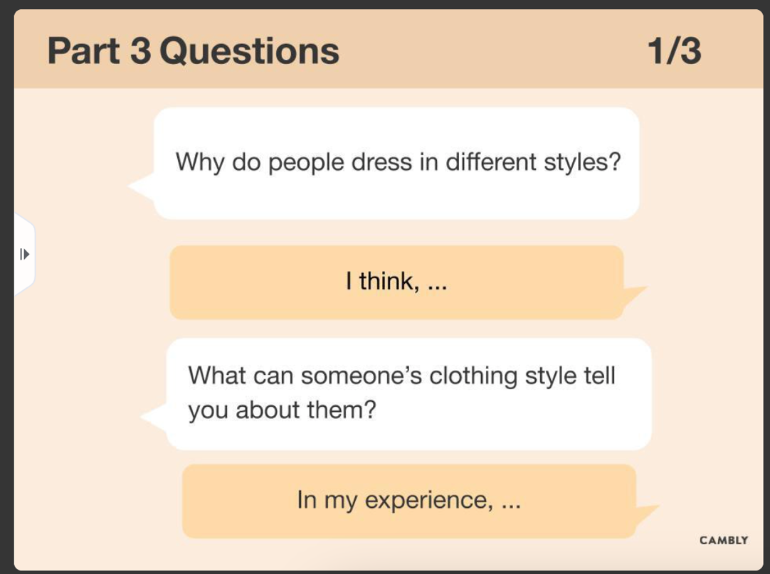
The boxes are linking themes, in this part of the test its about further discussion what you are thinking and how the world relates to the question.

IMPORTANT:
The most important thing to notice is that the topic of conversation would more or less stay the same as Question1. But the answers you give can be related to the first question. But it needs to be in - more detail (elaborated)
Personality
Wealth
Age

The colour codes relate to the different grammatical knowledge we need to use in our speaking.

Question1:
Why do people dress in different styles?

Your answer:

it depends on different situations because firstly this relates to the different countries we come from as in China we wear tradition clothes. Such as in America we wear more fashionable clothes and not traditionally.
In my opinion
Secondly it is related to age for the elderly people they are more focused on clothes are
more focused on being warm. Younger people show their preference to more fashionable clothes that show their personality. Thirdly it depends on gender, and for women they wear a dress with sleeves and for men they wear jeans or some clothes with military designs like a solider. The last thing different personality wear more different clothes.
Positive feedback: The things that went well
The answer you gave was nicely ordered in sequence by using words like, first, second and third. I like the use of the sentence starter in my opinion it would be best to continue to use such words.
Feedback: the things that can be worded on
Repeated words: Focus, or some, more, and – Please look at the synonyms and try to use them please this would be a big help in improving your score
Words not to use: something- avoid this word as it is vague and be left to interpretation as you don’t know what you are talking about.
Sentence starters: Try to use more of them -Try to use more of these to make your speaking more engaging.
Synonyms: Words that have the same meaning but show case vocabulary
Focus:
Pay attention to, what is most important, the intention, the need, what is more relevant
More:
Increasingly, in addition to, to add, another point,

Question1:
Why do people dress in different styles?

Model Answer:
Introduction, point, evidence, explain
Introduction Introduction,
There are a number of reasons why the styles and trends in fashion differ at the moment. We need to take into consider the following characteristics of way people’s style in any country could be different.

For example, I do believe that our age, gender, personality, country and culture are all themes that affect a person’s sense of style. If we look at the person wearing any piece of clothing, we can often immediately identify what gender they are based on the colour, shape and fit of the clothing. This is attributed to the fact that men and women have different physiques, yet the trends of social media tend to blur or even accentuate these unique features between genders depending on how the person identifies themself.
Point and evidence

As I have mentioned the colour of clothing can be a huge marker in differentiating sense of style, while also being a method to emphasis beauty in women. In my perspective in terms of fashion women are more likely to have varied styles due to the fact that they have the capacity to wear a varied range of types and styles of clothing as it has become socially acceptable for women to even clothes like trousers which were atypically reserved for men in the early 19th century. Although, in the future I believe fashion may become increasingly eclectic based on identities and influences from technology.
Explain

IMPORTANT:
The way you speak is the way you should write also. So, after recording yourself answer questions and listening to it. I would advise you to type Model answers for the question to practice your writing skills. This is doing two in one. So, if it were me, I would answer two questions in the morning before you leave the house. Just audio record it. You can send it to me via We chat if you want, and I can help with that. Then on your journey home listen to your answer and type notes of how to improve. Then the following morning on the journey to work type you model answer on your phone. If you wish to share that too, please let me know and I will share my We Chat ID.

Question 2:
What can a person’s clothing style tell you about them

I think many first all it’s about the personality, for example wears colourful clothes they are extroverted and if someone wears dark clothes they are introverted or in a bad mood. Second another thing is that it can show different kinds of wealth for example if someone wears luxurious cloths, they are rich and have a lot of money. If someone wears cheap clothes and do not have much money. Finally, I think it shows different age and if someone wears clothes with cartoons. I think they are young, and they are a kid. But if someone wears some looks clothes that look old clothes, they are elderly people.

