Price Control

Why government implement indirect tax or subsidy
Indirect Tax | Subsidy
Correct market failure
Reduce demerit goods = reduce negative externality => reduce the production or consumption of demerit goods | Increase merit goods = increase positive externality => increase the production or consumption of merit goods
Revenue | Spending
Reduce import | Increase export
Cigarettes  Alcohol | Necessities (food)  Vaccination

Tax or subsidy = > shift of supply curve
=> stakeholders effect (who gain, who lose)
=> producers, consumers, government, society

Consequences
Indirect Tax | Subsidy
Misallocation of Resources (under or over production)
Welfare loss to Society
Revenue received can be spent on healthcare or education | Opportunity cost => money could be spent on healthcare or education
Budget surplus | Budget deficit

Price Control: Government intervention

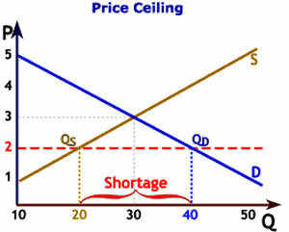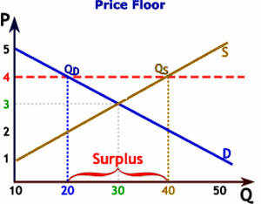

Price Ceiling | Price Floor
Max price => Below equilibrium price | MIn price =>Above equilibrium price
Protect Consumers (eg. the poor) | Protect Producers (eg. the farmers)  Protect workers (minimum wages)
Eg: Housing price, Rent, Education, Vaccination | Eg: Primary commodity - agriculture products rice, wheat, potatoes, coal, mineral
The quantity demanded after the price ceiling is imposed is Qd. The quantity supplied is Qs. Shortage of supply of (Qd-Qs). Price decreases, 3 → 2 (shortages results) | The quantity demanded after the price ceiling is imposed is Qd. The quantity supplied is Qs. Surplus of supply of (Qd-Qs). Price increases, 3 → 4 (surplus result)
Consequences
Misallocation of Resources => welfare loss
Blackmarket | Excess Supply
Non-price mechanism => rationing based on first come first serve, needs basis | Protecting high cost, inefficient local producers
Increase in unemployment as a result of lower output by producers
Consumer Gain: Consumers who buy the good at the lower price gain: those who want to buy it but cannot due to the shortage lose. This can be seen from the welfare analysis, which shows the gain by consumers of a portion of producer surplus due to the lower price paid (the blue area), and the loss of a portion of consumer surplus due to warfare loss. | Consumer Lose: Consumers need to pay a higher price for a lower quantity purchased. Loss of consumer surplus.
Producer Lose: Producers sell a lower quantity since they are imposed to sell their goods on a lower price. Producer revenue decreases from 30*3 to 20*2 | Producer Gain: producer can sell their goods at a higher price and sell in a higher quantity. Producer surplus increase
Government No Gain or Lose: Government does not receive tax revenue or spend on subsidy. But may gain politically from lowering the price of essentials. | Government Lose: Government has to buy the excess supply from the producers. This represents an opportunity cost, where money could be used for other purposes - education, infrastructure, healthcare etc.  Storage issue: where to store the excess, and also the cost of storage.  Export at a lower price (lose to the government).  Buy and destroy the excess supply.  For Minimum wages: excess supply of labour as cost of hiring increases. This could lead to higher unemployment. Unemployed people may take up jobs (pay by cash) at below the minimum wage level creating an underground (gray) economy.
Solutions
Government make up the shortages:  Housing - HDB flats (public subsidies flats)  Private house owners => spend little or no money to maintain the exterior and interior of the houses. This leads to poorer living conditions. Exterior deterioration of the building results in lower property prices. | Government buy the excess  Thai Government buying excess rice from farmers.

