Capital Investment Appraisal Report
Seagull Publishers – CRM Software Implementation

Introduction

Jonathan Eagleton, Seagull Publishers' proprietor, saw a great opportunity to modernise customer relationship management by implementing a CRM (Customer Relationship Management) package. The business, although profitable, has challenges when it comes to communication systems and high debtor days. The customer interaction system being considered aims to eradicate manual handling of customer interactions, reduce error rates, and boost cash collection activities.

This analysis analyzes the economic viability of investing £150,000 in the CRM system by the application of the techniques of capital investment appraisal, Net Present Value (NPV), and Internal Rate of Return (IRR). A 12% discount rate is assumed for NPV, and anything above 18% IRR is acceptable for Jonathan.

Project Overview

Item | Details
Project | CRM Software System
Initial Investment | £150,000
Project Life Span | 4 years
Expected Annual Cash Inflows | Year 1: £30,000  Year 2: £35,000  Year 3: £70,000  Year 4: £90,000
Discount Rate | 12%
Benchmark IRR | 18%

Net Present Value (NPV) Calculation



Year | Cash Flow (£) | Discount Factor (12%) | Present Value (£)
1 | 30,000 | 0.893 | 26,790
2 | 35,000 | 0.797 | 27,895
3 | 70,000 | 0.712 | 49,840
4 | 90,000 | 0.636 | 57,240
 |  |  | 161,765
Total Present Value = £161,765
Initial Investment = £150,000
NPV = £161,765 – £150,000 = £11,765
✅ Positive NPV indicates the project adds value.

Internal Rate of Return (IRR) Estimation

IRR is the discount rate that makes NPV = 0.

Rate | NPV (£)
12% | +11,765
20% | –16,810
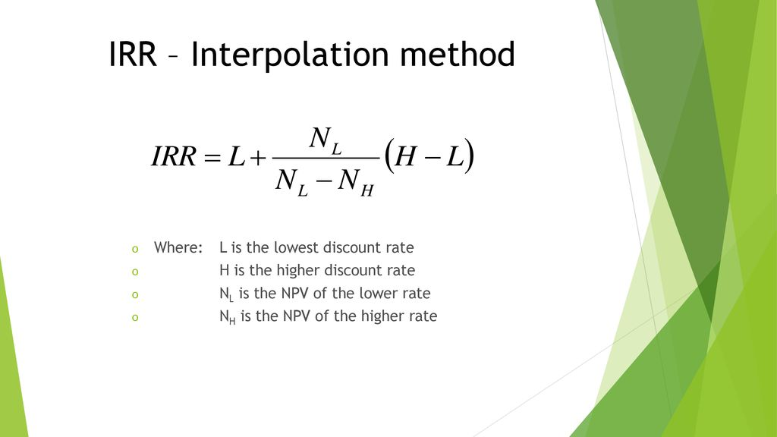

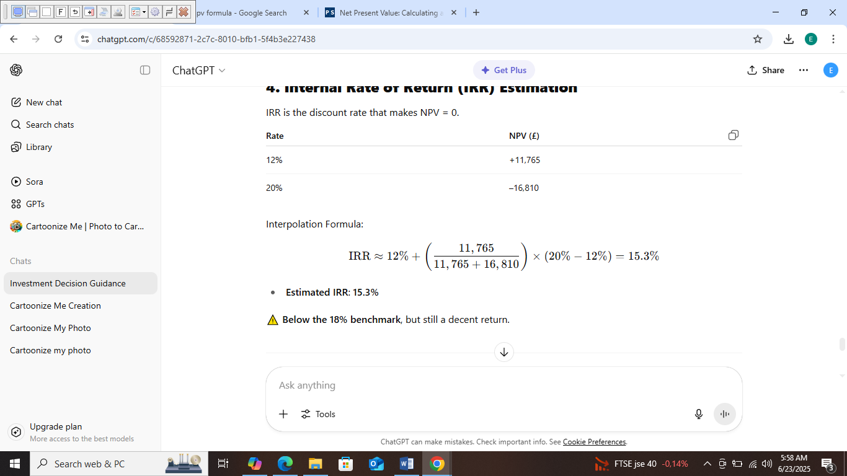

Payback Period Method

The Payback Period is the time it takes for an investment to recover its initial cost from the net cash inflows. It ignores the time value of money.
Formula:
Payback Period: Time until cumulative cash flow = initial investment

Initial Investment: £150,000

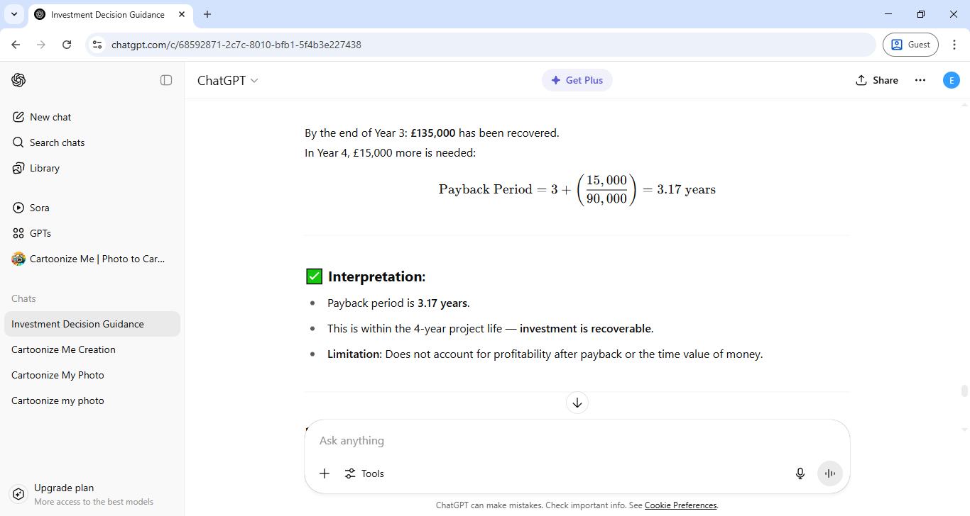

Difference Between Cash and Profit
Aspect | Cash | Profit
Definition | The actual money available in the business (e.g. in the bank or on hand). | The surplus remaining after all expenses have been deducted from revenue.
Basis | Based on actual cash inflows and outflows. | Based on accounting principles (includes non-cash items like depreciation).
Timing | Records when money is received or paid. | Records when income is earned and expenses incurred (accrual basis).
Example | Receiving a customer payment. | Earning income on credit, even if not yet paid.

Importance of Cash in Accounting Processes
- Liquidity Management:
  - Cash is essential for daily operations—paying suppliers, staff, rent, etc.
  - Seagull Publishers is concerned about high debtor days, which can create cash flow issues, even if the business is profitable on paper.
- Solvency:
  - A company can be profitable but still go bankrupt if it runs out of cash.
  - The CRM system is aimed at improving cash collection and reducing debtor days, thus strengthening cash flow.
- Investment Feasibility:
  - Cash is needed to finance the £150,000 CRM investment.
  - Jonathan must ensure the business can cover the upfront cost without risking operations.

Importance of Profit in Accounting Processes
- Performance Measurement:
  - Profit shows whether the company is creating value.
  - Over time, improved customer relationships should lead to higher sales and greater profitability.
- Decision Making:
  - Profit figures guide long-term planning, pricing, and cost control.
  - In this case, Jonathan assessed the CRM system's projected income (£225,000 over 4 years) against the cost to estimate profitability.
- Reporting & Compliance:
  - Profit is used in financial reporting, tax calculations, and performance evaluations.

In the Context of the CRM Investment
- Cash Relevance:
  - The CRM system's main goal is to improve cash collection by reducing debtor days through better communication (emails, reminders).
  - This strengthens working capital and ensures the company can meet obligations.
- Profit Relevance:
  - While the CRM will improve cash flow, its impact on profit comes from reduced bad debts and increased customer retention.
  - Jonathan used profit-based forecasts (projected returns per year) to assess if the system is worth the investment.

Both cash and profit are essential but serve different purposes:
- Cash ensures operational survival — without it, even profitable companies can collapse.
- Profit ensures long-term sustainability and growth — it reflects the company's ability to create value.
In Jonathan’s case, investing in the CRM system improves both:
- Cash: by accelerating collections and reducing debtor risk.
- Profit: by enhancing customer satisfaction and reducing costs from errors and bad debts.

The Role of Budgets in Investment Decisions
Budgets are essential planning tools in business. In the context of Seagull Publishers' potential £150,000 investment in a CRM system, a budget plays several critical roles:

1. Financial Planning & Control
Role:
- A budget outlines how the business will allocate funds to cover the CRM investment and associated costs (e.g. installation, training, maintenance).
Implication:
- Ensures Seagull Publishers doesn’t overextend financially.
- Helps Jonathan plan for cash flow timing (e.g. upfront payment vs staggered costs).
- Enables monitoring to ensure spending stays within limits.

2. Forecasting Revenue & Cost Impacts
Role:
- Budgets project the expected income from the CRM system (e.g. £30,000 to £90,000/year) and ongoing operational savings (e.g. fewer bad debts, faster collections).
Implication:
- Allows Jonathan to assess whether the investment is affordable and profitable over time.
- Helps evaluate return on investment using budgeting data as a base for NPV or IRR.

3. Risk Management
Role:
- A well-prepared budget includes contingency planning for risks like:
  - Delays in CRM implementation
  - Lower-than-expected revenue improvements
  - Unexpected costs (e.g. staff retraining, system updates)
Implication:
- Allows Seagull Publishers to build in financial buffers and avoid disruption.
- Supports decision-making under uncertainty.

4. Performance Monitoring & Accountability
Role:
- Budgets set benchmarks for success — e.g., targets for reduced debtor days, customer retention, or increased cash flow.
Implication:
- Jonathan can track actual results against budget and adjust operations or strategy if needed.
- Helps evaluate the real effectiveness of the CRM system over time.

5. Communication & Coordination
Role:
- Budgets help communicate the financial rationale behind the CRM investment to staff, stakeholders, or potential financiers.
Implication:
- Enhances buy-in from team members who will be trained on the new system.
- Aligns departments (e.g. sales, finance) to a common financial goal linked to CRM implementation.

6. Financing & Capital Allocation
Role:
- The budget identifies how the CRM will be financed — through existing cash reserves, a loan, or reallocating funds from other areas.
Implication:
- Helps avoid cash flow problems or the need for emergency funding.
- Forces prioritisation: does the CRM system deliver more value than other uses of the same capital?

Key Budget Implications for the CRM Investment
Implication | Details
Cash flow planning | Ensure sufficient liquidity to cover the £150,000 upfront cost.
Short-term strain vs long-term gain | Budget shows when the investment “breaks even” (Year 3 or 4 in this case).
Opportunity cost | Budgeting compares CRM with other potential uses of capital.
Accountability | Staff performance can be reviewed against CRM-related targets.
Strategic alignment | Budget reflects whether the CRM supports broader business goals.

Budgets are not just financial documents — they are decision-making and risk management tools. For Jonathan and Seagull Publishers, the budget:
- Confirms the financial feasibility of the CRM investment.
- Helps forecast and evaluate the return from improved customer communication.
- Provides a baseline to monitor the investment’s success over time.
- Ensures the business remains financially disciplined, especially when cash is tight.
Without a carefully prepared budget, Jonathan would risk making an investment that looks good in theory but proves unaffordable or ineffective in practice.

1. Legal Issues
a. Data Protection & GDPR Compliance
- The CRM system will store and process customer data (e.g. names, emails, communication records).
- Under the UK General Data Protection Regulation (UK GDPR) and Data Protection Act 2018, the company must:
  - Have a lawful basis for collecting and processing data (e.g. consent, contract).
  - Ensure data security and limit access to only authorised staff.
  - Provide customers with rights to access, correct, or delete their data.
  - Sign a Data Processing Agreement (DPA) with the CRM vendor if they process data on your behalf.
Implication: Jonathan must ensure the CRM provider is GDPR-compliant and offers secure cloud storage, encryption, and regular audits.

b. Intellectual Property (IP)
- Ensure the business does not inadvertently breach IP rights of the software provider.
- Typically, CRM providers license the software; the business does not own it.
- Read the licence agreement carefully:
  - Usage limits (number of users/devices)
  - Modification restrictions
  - Termination clauses

c. Contract Law
- The agreement with the software vendor should be clear on:
  - Scope of work (installation, training, updates)
  - Payment terms and refund policy
  - Service Level Agreements (SLAs)
  - Dispute resolution process

2. Procurement Issues
a. Vendor Selection
- Must follow fair and transparent procurement practices:
  - Assess multiple suppliers (e.g. demonstrations, Request For Proposals)
  - Evaluate based on cost, functionality, support, and reputation
  - Conduct due diligence on the vendor’s financial stability and data handling policies

b. Cost Transparency
- Ensure full clarity on:
  - Upfront vs recurring costs (licence fees, updates, cloud storage)
  - Hidden charges (user upgrades, training, integrations)
  - Total Cost of Ownership (TCO)

c. Installation and Integration
- Procurement should include scope for:
  - Compatibility with existing systems (e.g. invoicing or email)
  - Staff training and support
  - Migration of historical customer data (with proper safeguards)

d. Exit Strategy
- What happens if the company wants to stop using the CRM?
  - Can you extract and keep your data?
  - Are there termination fees?
  - How is data deleted by the provider?

When investing in a CRM system in the UK, legal compliance (especially with data protection laws) and procurement best practices are essential to avoid financial, reputational, or operational risks.
Jonathan should:
- Review all contracts carefully (with legal advice if needed).
- Ensure GDPR compliance by both Seagull Publishers and the CRM provider.
- Select a vendor based on value, support, security, and flexibility, not just cost.

Conclusion & Recommendation

The financial appraisal shows:
- NPV is positive (£11,765), meaning the CRM investment will create value for Seagull Publishers.
- IRR is 15.3%, slightly below the desired 18%, but still a strong return given the strategic benefits.
Additionally, the CRM system is expected to:
- Improve communication with customers
- Reduce number of debtor days and bad debts
- Increase operational efficiency

Recommendation: Proceed with the investment.
While the IRR is slightly under the target, the overall financial and strategic advantages support moving forward with the CRM system.

