Economic Integration
This is an advocate for free trade.
However, trade blocs are formed and could be defined as “A trade bloc is a type of intergovernmental agreement, often part of a regional intergovernmental organization, where regional barriers to trade, (tariffs and non-tariff barriers) are reduced or eliminated among the participating states.
Trade blocs can be stand-alone agreements between several states (such as the North American Free Trade Agreement (NAFTA) or part of a regional organization (such as the European Union). Depending on the level of economic integration, trade blocs can fall into different categories, such as: preferential trading areas, free trade areas, customs unions, common markets and economic and monetary unions.
Advantages
There are five major advantages of trade bloc agreements: foreign direct investment, economies of scale, competition, trade effects, and market efficiency.
- Foreign Direct Investment: An increase in foreign direct investment results from trade blocs and benefits the economies of participating nations. Larger markets are created, resulting in lower costs to manufacture products locally.

- Economies of Scale: The larger markets created via trading blocs permit economies of scale. The average cost of production is decreased because mass production is allowed.

- Competition: Trade blocs bring manufacturers in numerous countries closer together, resulting in greater competition. Accordingly, the increased competition promotes greater efficiency within firms.

- Trade Effects Trade blocs eliminate tariffs, thus driving the cost of imports down. As a result, demand changes and consumers make purchases based on the lowest prices, allowing firms with a competitive advantage in production to thrive.

- Market Efficiency: The increased consumption experienced with changes in demand combines with a greater amount of products being manufactured to result in an efficient market.

- Market access and trade creation: Easier access to each other’s markets means that trade between members is likely to increase. Trade creation exists when free trade enables high cost domestic producers to be replaced by lower cost, and more efficient imports. Because low cost imports lead to lower priced imports, there is a 'consumption effect', with increased demand resulting from lower prices.

Disadvantages
The disadvantages, on the other hand, include: regionalism vs. multinationalism, loss of sovereignty, concessions, and interdependence.
- Regionalism: Trading blocs bear an inherent bias in favour of their participating countries. For example, NAFTA, a free trade agreement between the United States, Canada and Mexico, has contributed to an increased flow of trade among these three countries. Trade among NAFTA partners has risen to more than 80 percent of Mexican and Canadian trade and more than a third of U.S. trade, according to a 2009 report by the Council on Foreign Relations. However, regional economies establish tariffs and quotas that protect intra-regional trade from outside forces, according to the University of California Atlas of Global Inequality. Rather than pursuing a global trading regime within the World Trade Organization, which includes the majority of the world's countries, regional trade bloc countries contribute to regionalism rather than global integration.

- Loss of Sovereignty: A trading bloc, particularly when it is coupled with a political union, is likely to lead to at least partial loss of sovereignty for its participants. For example, the European Union, started as a trading bloc in 1957 by the Treaty of Rome, has transformed itself into a far-reaching political organization that deals not only with trade matters, but also with human rights, consumer protection, greenhouse gas emissions and other issues only marginally related.

- Concessions: No country wants to let foreign firms gain domestic market share at the expense of local companies without getting something in return. Any country that wants to join a trading bloc must be prepared to make concessions. For example, in trading blocs that involve developed and developing countries, such as bilateral agreements between the U.S. or the EU and relatively poor Asian, Latin American or African countries, the latter may have to allow multinational corporations to enter their home markets, making some local firms uncompetitive.

- Interdependence: Because trading blocs increase trade among participating countries, the countries become increasingly dependent on each other. A disruption of trade within a trading bloc as a result of a natural disaster, conflict or revolution may have severe consequences for the economies of all participating countries

- Distortion of trade: Trading blocs are likely to distort world trade and reduce the beneficial effects of specialisation and the exploitation of comparative advantage.

- Inefficiencies and trade diversion: Inefficient producers within the bloc can be protected from more efficient ones outside the bloc. For example, inefficient European farmers may be protected from low-cost imports from developing countries. Trade diversion arises when trade is diverted away from efficient producers who are based outside the trading area.

- Retaliation: The development of one regional trading bloc is likely to stimulate the development of others. This can lead to trade disputes, such as those between the EU and NAFTA, including the recent Boeing (US)/Airbus (EU) dispute. The EU and US have a long history of trade disputes, including the dispute over US steel tariffs, which were declared illegal by the WTO in 2005. In addition, there are the so-called beef wars with the US applying £60m tariffs on EU beef in response to the EU’s ban on US beef treated with hormones; and complaints to the WTO of each other’s generous agricultural support.

Some of the Common Terms Used:
A free trade area is a grouping of countries within which
- tariffs and non-tariff trade barriers between the members are generally abolished but with no common trade policy toward non-members. The North American Free Trade Area (NAFTA) and the European Free Trade Association (EFTA) are examples of free trade areas
A common market is a customs union with provisions to liberalise movement of regional production facts (people and capital).
Customs unions are arrangements among countries in which the parties do two things: (1) agree to allow free trade on products within the customs union, and (2) agree to a common external tariff (CET) with respect to imports from the rest of the world. Customs unions and preferential trade arrangements more generally have become increasingly important in recent years.
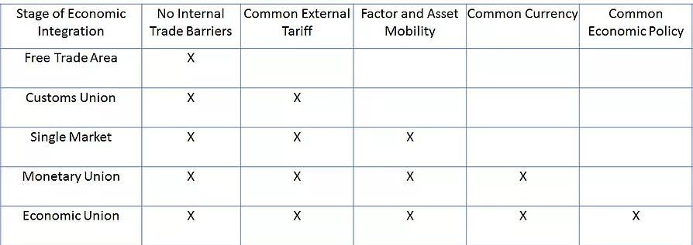
A currency union (also known as monetary union) involves two or more states sharing the same currency without them necessarily having any further integration (such as an economic and monetary union, which would have, in addition, a customs union and a single market). Example: Singapore Dollars and Brunei Dollars

Examples of Past Year Questions:
1. What would be the main difficulties involved in establishing a common currency for the whole world? If such a thing were attempted, what would be the advantages and disadvantages for an individual country, such as the one where you live or study?
2. Why are many international markets becoming dominated by a relatively small number of large companies? What are the economic consequences of this trend?
3. If protectionism is such a bad thing why have so many countries joined trading blocs?

