IB Biology Notes:

Topic 1: Cell Biology

Topic 1.3 Membrane Structure

Made by Brian Chia

Topic 1.3: Membrane structure

What is the plasma membrane?
- Made up of phospholipids
  - Phospholipids are amphipathic, which means part of the molecule is hydrophilic and part of it is hydrophobic
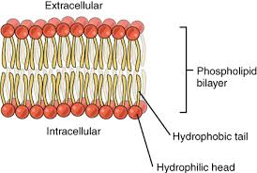

Davson-Danielli Model:
- In this model of the membrane, a bilayer of membranes exists in the centre with protein layers on either side
- This model was proposed as a result of electron microscopy
  - In the micrographs, membranes appeared as 2 dark lines separated by a lighter band
  - This made sense and backed up the model, as proteins appeared darker than lipids
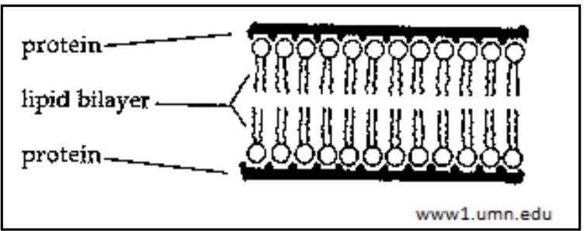
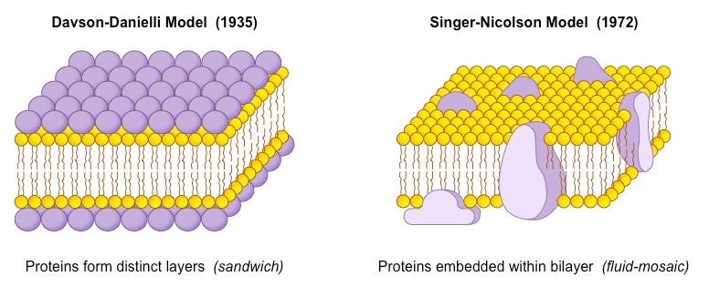

Falsification of the Davson-Danielli Model:
- Fluorescent tagging of membrane proteins:
  - Red or green fluorescent markers were attached to antibodies that bind to membrane proteins
  - Within 40 minutes, the red and green markers were mixed throughout the membrane
  - This proved that membrane proteins were free to move within the membrane rather than be fixed on the peripheral layer
- Freeze etched electron micrographs
  - A technique involving the rapid freezing of cells and then fracturing them
  - Fractured occurred along lines of weakness, such as centre of membrane
  - Globular structures scattered throughout the centre were interpreted as transmembrane proteins
- Structure of membrane proteins
  - Improvements in biochemical technology allowed proteins to extracted from cells and examined
  - Found that membrane proteins all varied in size and shape, unlike the proteins that would form consistent layers on the peripheral layer of the membrane

Singer-Nicholson Model (Fluid Mosaic Model):
- Falsification of the Davson-Danielli model led to the fluid mosaic model
- Instead of a peripheral layer of proteins, multiple types of membrane proteins would be present within the membrane and are free to move around

Phospholipid bilayer:
- Bilayers form due to the amphipathic properties of phospholipids
  - Phospholipid head is a negatively charged phosphate group, which is attracted to water due to polarity
  - 2 fatty acid tails have no charge, which is repelled by water
- When present in water, the phospholipids naturally form a bilayer with the tails facing each other towards the middle and the heads facing outward towards the water
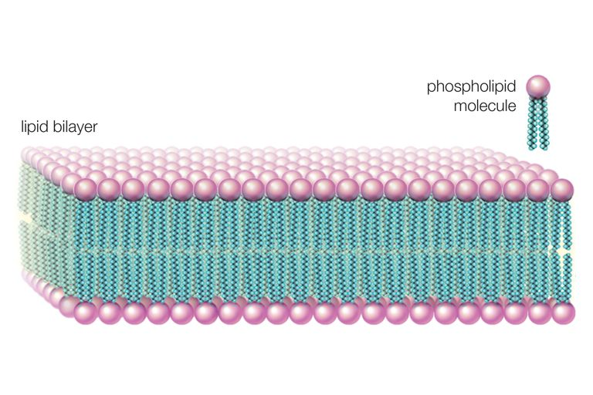
- Membrane is fluid like as they can move along the horizontal plane
Membrane proteins:
- Peripheral proteins:
  - Attached to an outer surface of the membrane
- Integral proteins:
  - Embedded in the phospholipid layer
- Glycoproteins:
  - Have a sugar (carbohydrate) unit attached to an outer membrane surface
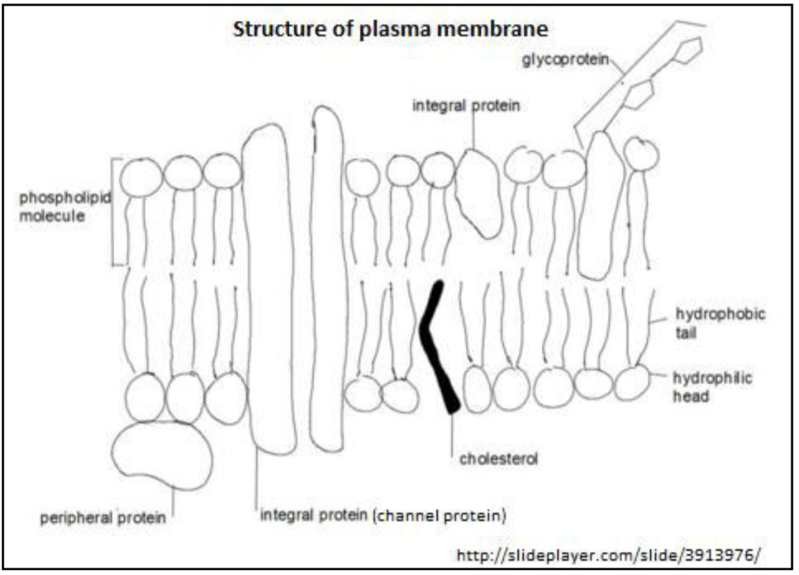

Functions of membrane proteins:
- Occupy a wide range of positions and functions:
- Hormone binding sites:
  - Hormones can bind to the proteins embedded in the membrane
  - Eg. Hormone receptors
- Cell adhesion:
  - Integral proteins can be used for cell-to-cell adhesion, for forming tight junctions between cells or tissues
- Channels for passive transport:
  - Specific proteins used for facilitated diffusion, provides a pathway for molecules to move from an area of high concentration to an area of low concentration
- Pumps for active transport:
  - Proteins that use ATP to move from an area of low concentration to an area of high concentration against the gradient
- Cell to cell communication:
  - Glycoproteins on the surface of the membrane are useful for cell recognition
  - Eg. Act as receptors for neurotransmitters between nerve cells
- Immobilized enzymes:
  - Proteins that catalyse specific chemical reactions
  - Eg. Small intestine
- Electron transport:
  - Certain peripheral proteins can act in the electron transport chain
Cholesterol in membrane:
- Most cholesterol is hydrophobic, therefore is embedded within the middle layers of the plasma membrane
- Cholesterol disrupts regular packing of hydrocarbon tails in phospholipid molecules
  - Prevents the crystallization of membrane
- Restricts fluidity and permeability for membrane
- Also provides firmness and integrity to prevent it from being over fluid

