Compare and contrast brain imaging technologies used in psychological research

With advancements in technology, brain imaging technologies are now often used when investigating the relationship between biological factors and behavior.

Some examples of brain imaging technologies regularly used to investigate this relationship are:
- PET (Positron Emission Topography)
- MRI and fMRI (Magnetic Resonance Imaging & Functional Magnetic Resonance imaging).
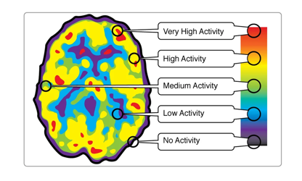
PET
- PET scan (positron emission tomography)
- Produces a three-dimensional image of functional processes in the body
- Can examine brain function, mapping actual activity in the brain over time
- The test is done by injecting a small amount of a radioactive material into one of your veins.
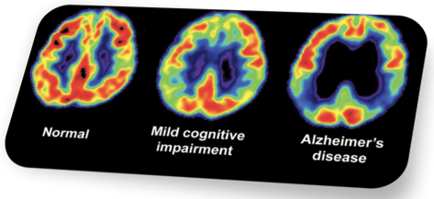
- The radioactive tracer used in the PET procedure is Fluorodeoxyglucose (FDG). The substance travels through the bloodstream and collects in organs and tissues and after a waiting period, which allows the substance to collect in the tissues of interest, the subject is placed on the imaging scanner.
- FDG serves as markers of blood flow or metabolic activity in the brain, which can provide a color-coded map indicating which areas of the brain become active when participants do a number of activities.
- Lower resolution compared to fMRI and MRI

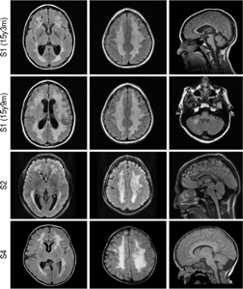
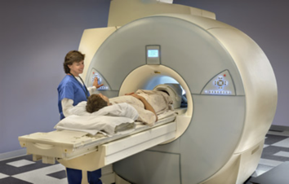
MRI
- MRI (Magnetic Resonance Imaging)
- Provides a three dimensional picture of brain structures (MRI images brain structures)
- High spatial resolution
- Especially useful for detecting small anatomical changes as a result of disease processes or trauma in the brain
- Used for correlating structural changes/differences in the brain (biological factors) with changes in behavior

FMRI
- fMRI (functional MRI)
- A more recent development in MRI technology
- Needs to be used together with MRI
- High temporal resolution
- Measuring blood flow (blood oxygenation actually in certain cases; when an area is more active, it uses more oxygen)
- fMRI images brain function.

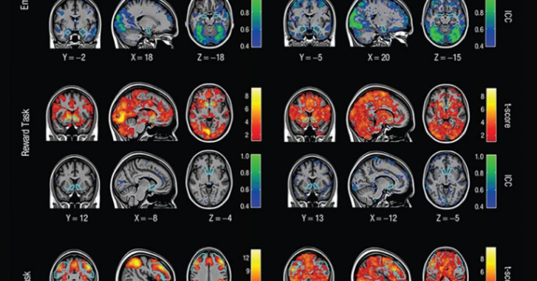

CT
- Computerized tomography (CT)
- Combines a series of X-ray images taken from different angles around your body
- Uses computer processing to create cross-sectional images (slices) of the bones, blood vessels and soft tissues inside your body.
- CT scan images provide more-detailed information than plain X-rays do.
- CT scans and MRIs are both used to capture images within your body. The biggest difference is that MRIs use radio waves and CT scans use X-rays.
- CT Scans are one of the few tests where your doctor or radiology can receive test results nearly immediately.
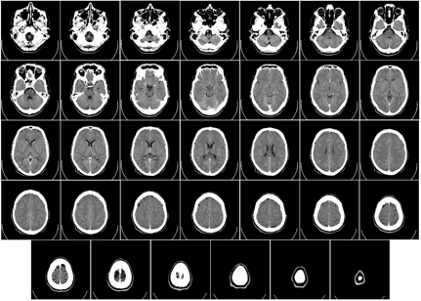
- Usually used if MRI is not an option for the patient/subject
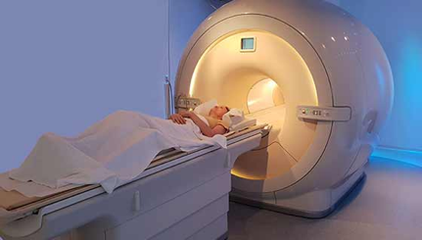

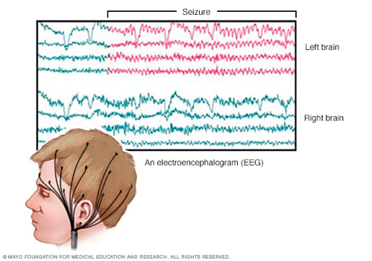
EEG
- electroencephalogram (EEG)
- detects electrical activity in your brain using small, metal discs (electrodes) attached to your scalp.
- Why it works: Your brain cells communicate via electrical impulses and are active all the time, even when you're asleep.
- Measures event-related potential (ERP).
- ERP is the measured brain response that is the direct result of a specific sensory, cognitive, or motor event (any stereotyped electrophysiological response to a stimulus).
- Noninvasive means of evaluating brain functioning.
- Extensively in neuroscience, cognitive science, cognitive psychology, neurolinguistics and psychophysiological research
- An EEG might also be helpful for diagnosing or treating the following disorders:
- Brain tumor
- Brain damage from head injury
- Brain dysfunction that can have a variety of causes (encephalopathy)
- Inflammation of the brain (encephalitis)
- Stroke
- Sleep disorders

Compare and Contrast:

PET | MRI | fMRI | EEG
Lower resolution compared to the other two brain imaging technologies | High spatial resolution | High temporal resolution | N/A, measures electrical impulses in the brain only
Most invasive - requires injection of radioactive substance (FDG) | Less invasive compared with PET | Less invasive compared with PET | Noninvasive means of evaluating brain functioning - least invasive out of the three
Relatively more comfortable than MRI | Least comfortable for patients/participants - may cause claustrophobic response and are required to lie still throughout | Relatively more comfortable than MRI | Have to sit still for test and fluid stuck on certain spots of the patients/participants’ scalp
Color-coded | Monotone (black and white) | Color-coded | Measures event-related potential (ERP) through electrical impulses in your brain
Examine brain function by blood flow/metabolic activity | Examine brain structure | Examine brain function by blood flow/blood oxygenation | Detects electrical activity in the brain
Expensive | Expensive | Expensive | Affordable
Big machine - not portable and requires large space to contain | Big machine - not portable and requires large space to contain | Big machine - not portable and requires large space to contain | Portable - only cap and chair required

Compare and Contrast:

MRI | CT | Both
Higher spatial resolution | Lower spatial resolution | Can provide cross section image of body parts
Uses radio waves - will not cause long term harm | Uses X-rays - slightly radioactive and may cause long term harm | Uncomfortable for patients/participants - may cause claustrophobic response and are required to lie still throughout
Results not available immediately to assess | Results available immediately | Examine brain structure
 |  | Monotone

Conclusion:
- There is no real 'advantage' for one over the other since they have different purposes and usually work together.

Sources:
https://guide.fariaedu.com/ib-psychology-guide/chapter-4-biological-approaches-to-understanding-behaviour#neural-networks

https://simplebooklet.com/NLm1Z29R0SdoHUJrrebgDR#page=20

https://www.nhs.uk/conditions/electroencephalogram/#:~:text=An%20electroencephalogram%20(EEG)%20is%20a,looked%20at%20by%20a%20doctor.

Niedermeyer E.; da Silva F.L. (2004). Electroencephalography: Basic Principles, Clinical Applications, and Related Fields. Lippincott Williams & Wilkins.

https://www.apa.org/topics/neuropsychology/brain-form-function#:~:text=Psychologists%20have%20used%20neuroimaging%20technology,people%20of%20different%20racial%20groups.

https://www.ncbi.nlm.nih.gov/pmc/articles/PMC2849100/

https://www.simplypsychology.org/neuroimaging.html

