Question 1
  - State in words the following assumptions underlying the simple linear regression model $y_{i}=β_{0}+β_{1}x_{i}+ϵ_{i}$, where $i=1,2,…,n$
    - The expected value of the error term corresponds to zero
    - The error term has a constant variance for all observations
    - The random error terms $∈_{i}$ are independent each other.
  - The Gauss-Markov Theorem states that, under certain conditions, the ordinary least squares (OLS) estimator of the coefficients of a linear regression model is the best linear unbiased estimator (BLUE), that is the estimator that has the smallest variance among those that are unbiased and linear in the observed output variables. For Gauss-Markov Theorem, we have if $E\left(y\right)=Xβ$ and $cov\left(y\right)=σ^{2}I$, the least-squares estimators ${\hat{β}}_{j}$, $j=0,1,…,k$ have minimum variance among all linear unbiased estimators.

  - We have the following information for simple linear regression:
$X=\left[\begin{matrix}1 & 10.1 \\ 1 & 7.7 \\ 1 & 10.8 \\ 1 & 3.3 \\ 1 & 9.2 \\ 1 & 5.8 \\ 1 & 10.1 \\ 1 & 10.1 \\ 1 & 13.2 \\ 1 & 6.4 \\ 1 & 13.3 \\ 1 & 6.5 \\ 1 & 19.7 \\ 1 & 8.5 \\ 1 & 5 \\ 1 & 6.4 \\ 1 & 4.1 \\ 1 & 9.8 \\ 1 & 6.2 \\ 1 & 4.7\end{matrix}\right]$ , $Y=\left[\begin{matrix}63 \\ 63 \\ 61 \\ 29 \\ 50 \\ 38 \\ 61 \\ 43 \\ 71 \\ 38 \\ 82 \\ 43 \\ 78 \\ 58 \\ 33 \\ 40 \\ 38 \\ 61 \\ 51 \\ 41\end{matrix}\right]$, $X^{'}X=\left[\begin{matrix}20 & 170.9 \\ 170.9 & 1745.15\end{matrix}\right]$ and $X^{'}Y=\left[\begin{matrix}1042 \\ 9870.3\end{matrix}\right]$
    - Let $X^{'}X=\left[\begin{matrix}a & b \\ c & d\end{matrix}\right]$, where a = 20, b = 170.9, c = 170.9 and d = 1745.15, then ${\left(X'X\right)}^{-1}=\frac{1}{ad-bc}\left[\begin{matrix}d & -b \\ -c & a\end{matrix}\right]$
${\left(X'X\right)}^{-1}=\frac{1}{\left(20\right)\left(1745.15\right)-\left(170.9\right)\left(170.9\right)}\left[\begin{matrix}1745.15 & -170.9 \\ -170.9 & 20\end{matrix}\right]$
${\left(X'X\right)}^{-1}=\frac{1}{5696.19}\left[\begin{matrix}1745.15 & -170.9 \\ -170.9 & 20\end{matrix}\right]=\left[\begin{matrix}0.3063714518 & -0.03000251045 \\ -0.03000251045 & 0.003511118836\end{matrix}\right]$
$\hat{β}=\left[\begin{matrix}{\hat{β}}_{0} \\ {\hat{β}}_{1}\end{matrix}\right]={\left(X^{'}X\right)}^{-1}\left(X^{'}Y\right)$
$\hat{β}=\left[\begin{matrix}{\hat{β}}_{0} \\ {\hat{β}}_{1}\end{matrix}\right]=\left[\begin{matrix}0.3063714518 & -0.03000251045 \\ -0.03000251045 & 0.003511118836\end{matrix}\right] \left[\begin{matrix}1042 \\ 9870.3\end{matrix}\right]=\left[\begin{matrix}23.10527 \\ 3.39318\end{matrix}\right]$
    - The fitted equation is $\hat{y}=23.1053+3.3932x$
${\hat{β}}_{0}=23.1053$, this means that when total salaries are zero pound, the expected number of points earned for English Premier League Teams correspond approximately to 24 points.
${\hat{β}}_{1}=3.3932$, this means that for every increase in total salaries by one (in million pounds), we can expect an increase on points earned by 3.3932 (in million pounds).

    - The null and alternative hypothesizes are: $H_{0}:β_{1}=0$ versus $H_{1}:β_{1}≠0$
Let find the SST, SSR and SSE using matrices operation.
SSE = SST – SSR
$SST=Y^{'}Y-CF$
$Y^{'}Y=\left[\begin{matrix}63 & 63 & 61 & 29 & 50 & 38 & 61 & 43 & 71 & 38 & 82 & 43 & 78 & 58 & 33 & 40 & 38 & 61 & 51 & 41\end{matrix}\right]\left[\begin{matrix}63 \\ 63 \\ 61 \\ 29 \\ 50 \\ 38 \\ 61 \\ 43 \\ 71 \\ 38 \\ 82 \\ 43 \\ 78 \\ 58 \\ 33 \\ 40 \\ 38 \\ 61 \\ 51 \\ 41\end{matrix}\right]$
$Y^{'}Y=58656$
$CF=\frac{{\left(63+63+61+29+50+38+61+43+71+38+82+43+78+58+33+40+38+61+51+41\right)}^{2}}{20}$
$CF=\frac{{\left(1042\right)}^{2}}{20}=54288.20$
$SST=58656-54288.2=4367.80$
$SSR={\hat{β}}^{'}X^{'}Y-CF=\left[\begin{matrix}23.1053 & 3.3932\end{matrix}\right]\left[\begin{matrix}1042 \\ 9870.3\end{matrix}\right]-54288.2$
$SSR=57567.40342-54288.2=3279.20342$
SSE = SST – SSR = 4367.8 – 3279.20342 = 1088.59658
$σ^{2}=\frac{SSE}{n-p}=\frac{1088.59658}{20-2}=60.47758778$
Covariance matrix $cov\left(β_{i},β_{j}\right)=σ^{2}{\left(X^{'}X\right)}^{-1}$
$σ^{2}{\left(X'X\right)}^{-1}=60.47758778\left[\begin{matrix}0.3063714518 & -0.03000251045 \\ -0.03000251045 & 0.003511118836\end{matrix}\right]$
$σ^{2}{\left(X'X\right)}^{-1}=\left[\begin{matrix}18.52860 & -1.81447 \\ -1.81447 & 0.21234\end{matrix}\right]$
$var\left({\hat{β}}_{1}\right)=\left(60.47758778\right)\left(0.003511118836\right)=0.21234$
The t-statistic is $t=\frac{{\hat{β}}_{1}}{\sqrt{var\left({\hat{β}}_{1}\right)}}=\frac{3.39318}{\sqrt{0.21234}}=7.36$
The critical value is $t_{\frac{α}{2}, n-p}=t_{0.025, 18}=2.101$
Rejection region: Reject the null hypothesis $H_{0}$ is the statistic test $t>$ $t_{\frac{α}{2}, n-p}$
Conclusion: since $t=7.36>2.10$, the null hypothesis $H_{0}$ is rejected at 5% significant level.
    - 95% confidence interval for $β_{1}$ is ${\hat{β}}_{1}±t_{\frac{α}{2}, n-p}\sqrt{var\left({\hat{β}}_{1}\right)}$
⇒ $3.39318±\left(2.101\right)\left(\sqrt{0.21234}\right)$
⇒ $3.39318±0.968122=\left(2.4251, 4.3613\right)$
Conclusion: since the 95% confidence interval for $β_{1}$ doesn’t include zero, the null hypothesis $H_{0}$ is rejected and this conclusion also supports the answer obtained in part (1.3.3) and the slope of this simple linear regression is statistically significant.
Question 2
The multiple linear regression regarding this question can be written as:
$y_{i}=β_{0}+β_{1}x_{1}+β_{2}x_{2}+β_{3}x_{3}+∈_{i}$

2.1 the design matrix corresponds to:
$X=\left[\begin{matrix}1 & 162 & 23 & 3 \\ 1 & 162 & 23 & 8 \\ 1 & 162 & 30 & 5 \\ 1 & 162 & 30 & 8 \\ 1 & 172 & 25 & 5 \\ 1 & 172 & 25 & 8 \\ 1 & 172 & 30 & 5 \\ 1 & 172 & 30 & 8 \\ 1 & 167 & 27.5 & 6.5 \\ 1 & 177 & 27.5 & 6.5 \\ 1 & 157 & 27.5 & 6.5 \\ 1 & 167 & 32.5 & 6.5 \\ 1 & 167 & 22.5 & 6.5 \\ 1 & 167 & 27.5 & 9.5 \\ 1 & 167 & 27.5 & 3.5 \\ 1 & 177 & 20 & 6.5 \\ 1 & 177 & 20 & 6.5 \\ 1 & 160 & 34 & 7.5 \\ 1 & 160 & 34 & 7.5\end{matrix}\right]$
2.2 List and explain four assumptions underlying a multiple linear regression model
The four assumptions underlying a multiple regression model are:
- Linear relationship
There exists a linear relationship between each predictor variable and the response variable. The easiest way to determine if this assumption is met is to create a scatter plot of each predictor variable and the response variable.
This allows us to see if there is a linear relationship between two variables. If the points in the scatter plot roughly fall along a straight line, then there likely exists a linear relationship.
- No multicollinearity
Multiple linear regression assumes that none of the predictor variables are highly correlated with each other. when one or more predictor variables are highly correlated, the regression mode suffers from multicollinearity, which causes the coefficient estimates in the model to become unreliable.

- Independence

Multiple linear regression assumes that each observation in the dataset is independent. The simplest way to determine if the assumption is met is to perform a Durbin-Watson test, which is a formal statistical test that tells us whether or not the residuals exhibit autocorrelation.
- Homoscedasticity
Multiple linear regression assumes that the residuals have constant variance at every point in the linear model. when this is not the case, the residuals are said to suffer from heteroscedasticity. when heteroscedasticity is present in a regression analysis, the results of the regression model become unreliable.
MULTIVARIATE NORMALITY
Multiple linear regression assumes that the residuals of the model are normally distributed.
2.3 In the case where the data does not satisfy all or some assumptions listed in part 2.2, what should a statistician do?
In the case where the data does not satisfy all or some assumptions listed in part 2.2, then we have a couple of options: -
when statistical assumptions for regression cannot be met, then a statistician must pick a different method or one can apply non -parametric tests e.g. chi-square in place of correlation. Non -parametric tests such as sample Wilcoxon, mann-whitney, Kruskal-Wallis.
- If the linear relationship assumption is not met, we can apply a non-linear transformation to the predictor variable such as taking the log or the square root or adding another predictor variable to the model.
- If the independence assumption is not met, then for positive serial correlation consider adding lags of the dependent and or independent variable to the model
- common ways to fix heteroscedasticity
Transform the response variable
Redefine the response variable'
Use weighted regression
- If the normality assumption is not met then first verify that there are no extreme outliers present in the data that causes the normality assumption to be violated.

2.4 Give the fitted equation of the multiple linear regression model
$X=\left[\begin{matrix}1 & 162 & 23 & 3 \\ 1 & 162 & 23 & 8 \\ 1 & 162 & 30 & 5 \\ 1 & 162 & 30 & 8 \\ 1 & 172 & 25 & 5 \\ 1 & 172 & 25 & 8 \\ 1 & 172 & 30 & 5 \\ 1 & 172 & 30 & 8 \\ 1 & 167 & 27.5 & 6.5 \\ 1 & 177 & 27.5 & 6.5 \\ 1 & 157 & 27.5 & 6.5 \\ 1 & 167 & 32.5 & 6.5 \\ 1 & 167 & 22.5 & 6.5 \\ 1 & 167 & 27.5 & 9.5 \\ 1 & 167 & 27.5 & 3.5 \\ 1 & 177 & 20 & 6.5 \\ 1 & 177 & 20 & 6.5 \\ 1 & 160 & 34 & 7.5 \\ 1 & 160 & 34 & 7.5\end{matrix}\right]$ $Y=\left[\begin{matrix}41.5 \\ 33.7 \\ 27.7 \\ 21.7 \\ 19.9 \\ 15 \\ 12.2 \\ 4.3 \\ 19.3 \\ 6.4 \\ 37.6 \\ 18 \\ 26.3 \\ 9.9 \\ 25 \\ 14.1 \\ 15.2 \\ 15.9 \\ 19.6\end{matrix}\right]$, $X^{'}X=\left[\begin{matrix}19 & 3179 & 516.5 & 123.5 \\ 3179 & 532593 & 86199.5 & 20659.5 \\ 516.5 & 86199.5 & 14363.75 & 3379.25 \\ 123.5 & 20659.5 & 3379.25 & 850.75\end{matrix}\right]$ and $X^{'}Y=\left[\begin{matrix}383.3 \\ 63377.6 \\ 10249.35 \\ 2358.75\end{matrix}\right]$
y | x₁ | x₂ | x₃ | yx₁ | yx₂ | yx₃ | x₁x₂ | x₁x₃ | x₂x₃ | x₁² | x₂² | x₃²
41.5 | 162 | 23 | 3 | 6723 | 954.5 | 124.5 | 3726 | 486 | 69 | 26244 | 529 | 9
33.7 | 162 | 23 | 8 | 5459.4 | 775.1 | 269.6 | 3726 | 1296 | 184 | 26244 | 529 | 64
27.7 | 162 | 30 | 5 | 4487.4 | 831 | 138.5 | 4860 | 810 | 150 | 26244 | 900 | 25
21.7 | 162 | 30 | 8 | 3515.4 | 651 | 173.6 | 4860 | 1296 | 240 | 26244 | 900 | 64
19.9 | 172 | 25 | 5 | 3422.8 | 497.5 | 99.5 | 4300 | 860 | 125 | 29584 | 625 | 25
15 | 172 | 25 | 8 | 2580 | 375 | 120 | 4300 | 1376 | 200 | 29584 | 625 | 64
12.2 | 172 | 30 | 5 | 2098.4 | 366 | 61 | 5160 | 860 | 150 | 29584 | 900 | 25
4.3 | 172 | 30 | 8 | 739.6 | 129 | 34.4 | 5160 | 1376 | 240 | 29584 | 900 | 64
19.3 | 167 | 27.5 | 6.5 | 3223.1 | 530.75 | 125.45 | 4592.5 | 1085.5 | 178.75 | 27889 | 756.25 | 42.25
6.4 | 177 | 27.5 | 6.5 | 1132.8 | 176 | 41.6 | 4867.5 | 1150.5 | 178.75 | 31329 | 756.25 | 42.25
37.6 | 157 | 27.5 | 6.5 | 5903.2 | 1034 | 244.4 | 4317.5 | 1020.5 | 178.75 | 24649 | 756.25 | 42.25
18 | 167 | 32.5 | 6.5 | 3006 | 585 | 117 | 5427.5 | 1085.5 | 211.25 | 27889 | 1056.25 | 42.25
26.3 | 167 | 22.5 | 6.5 | 4392.1 | 591.75 | 170.95 | 3757.5 | 1085.5 | 146.25 | 27889 | 506.25 | 42.25
9.9 | 167 | 27.5 | 9.5 | 1653.3 | 272.25 | 94.05 | 4592.5 | 1586.5 | 261.25 | 27889 | 756.25 | 90.25
25 | 167 | 27.5 | 3.5 | 4175 | 687.5 | 87.5 | 4592.5 | 584.5 | 96.25 | 27889 | 756.25 | 12.25
14.1 | 177 | 20 | 6.5 | 2495.7 | 282 | 91.65 | 3540 | 1150.5 | 130 | 31329 | 400 | 42.25
15.2 | 177 | 20 | 6.5 | 2690.4 | 304 | 98.8 | 3540 | 1150.5 | 130 | 31329 | 400 | 42.25
15.9 | 160 | 34 | 7.5 | 2544 | 540.6 | 119.25 | 5440 | 1200 | 255 | 25600 | 1156 | 56.25
19.6 | 160 | 34 | 7.5 | 3136 | 666.4 | 147 | 5440 | 1200 | 255 | 25600 | 1156 | 56.25
383.3 | 3179 | 516.5 | 123.5 | 63377.6 | 10249.35 | 2358.75 | 86199.5 | 20659.5 | 3379.25 | 532593 | 14363.75 | 850.75
Now to find the inverse of X’X, we can use Excel function minverse as below:
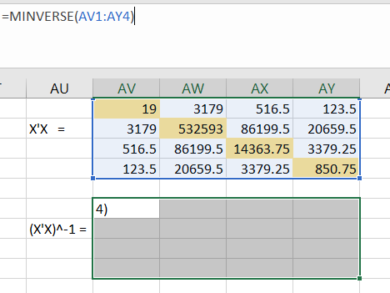
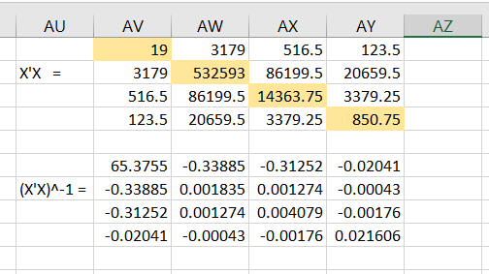
Now the inverse of X’X is:

$${\left(X^{'}X\right)}^{-1}=\left[\begin{matrix}65.375502031768 & -0.338847001530 & -0.312524384001 & -0.020413574127 \\ -0.338847001530 & 0.001834993301 & 0.001273688830 & -0.000430857939 \\ -0.312524384001 & 0.001273688830 & 0.004078745636 & -0.001763284347 \\ -0.020413574127 & -0.000430857939 & -0.001763284347 & 0.021605600498\end{matrix}\right]$$

Now, $\hat{β}=\left[\begin{matrix}{\hat{β}}_{0} \\ {\hat{β}}_{1} \\ {\hat{β}}_{2} \\ {\hat{β}}_{3}\end{matrix}\right]={\left(X^{'}X\right)}^{-1}\left(X^{'}Y\right)$
$\hat{β}=\left[\begin{matrix}65.375502031768 & -0.338847001530 & -0.312524384001 & -0.020413574127 \\ -0.338847001530 & 0.001834993301 & 0.001273688830 & -0.000430857939 \\ -0.312524384001 & 0.001273688830 & 0.004078745636 & -0.001763284347 \\ -0.020413574127 & -0.000430857939 & -0.001763284347 & 0.021605600498\end{matrix}\right]\left[\begin{matrix}383.3 \\ 63377.6 \\ 10249.35 \\ 2358.75\end{matrix}\right]$
$\hat{β}=\left[\begin{matrix}331.7979 \\ -1.54439 \\ -1.42191 \\ -2.24157\end{matrix}\right]$
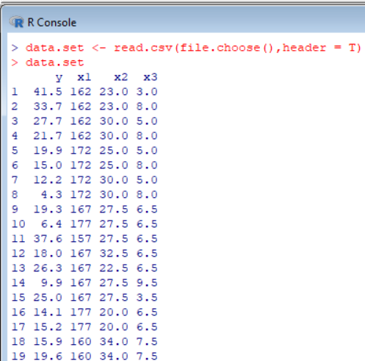
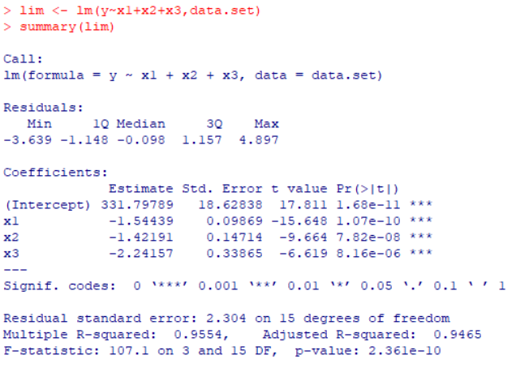
The fitted equation of this multiple linear regression model is:
$\hat{y}=331.7979-1.54439x_{1}-1.42191x_{2}-2.24157x_{3}$
2.5 Plot the residuals e against the fitted values $\hat{y}$ and the residuals e against the observed values 𝒚. What can you say about the adequacy of the model?
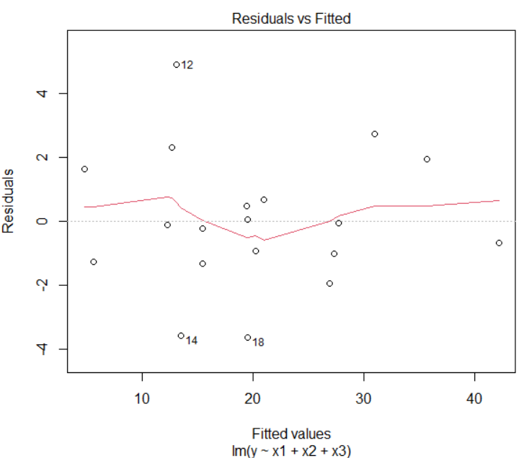
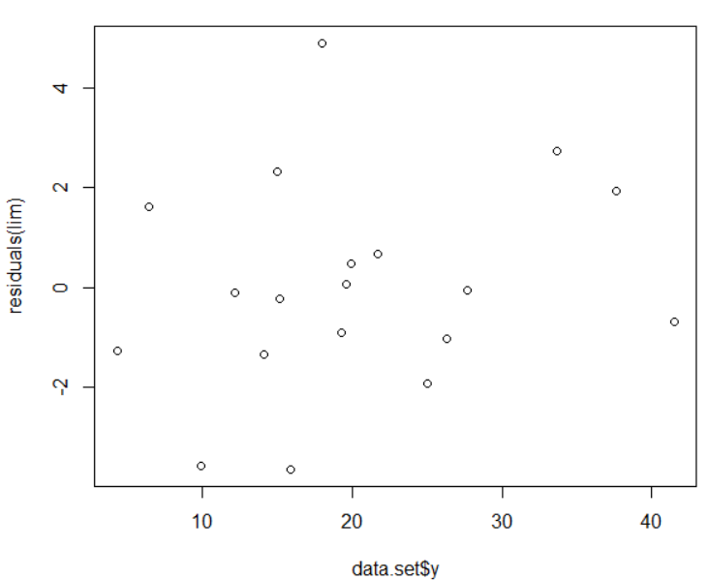
Observing the graphs above, the constant variance assumption seems to be satisfied since the residuals are randomly scattered and centered around 0 with no pattern identified.
2.6. To access each test related to each coefficient of regression, we must first find SST, SSE and SSR.
SSE = SST – SSR
$SST=Y^{'}Y-CF$
$Y^{'}Y=\left[\begin{matrix}41.5 & 33.7 & 27.7 & 21.7 & 19.9 & 15 & 12.2 & 4.3 & 19.3 & 6.4 & 37.6 & 18 & 26.3 & 9.9 & 25 & 14.1 & 15.2 & 15.9 & 19.6\end{matrix}\right]\left[\begin{matrix}41.5 \\ 33.7 \\ 27.7 \\ 21.7 \\ 19.9 \\ 15 \\ 12.2 \\ 4.3 \\ 19.3 \\ 6.4 \\ 37.6 \\ 18 \\ 26.3 \\ 9.9 \\ 25 \\ 14.1 \\ 15.2 \\ 15.9 \\ 19.6\end{matrix}\right]$
$Y^{'}Y=9517.19$

$CF=\frac{{\left(41.5+33.7+27.7+21.7+19.9+15+12.2+4.3+19.3+6.4+37.6+18+26.3+9.9+25+14.1+15.2+15.9+19.6\right)}^{2}}{19}$
$CF=\frac{{\left(383.3\right)}^{2}}{19}$= $7732.57315789474$
$SST=9517.19-7732.5731578974=$ 1784.6168
$SSR={\hat{β}}^{'}X^{'}Y-CF=\left[\begin{matrix}331.7979 & -1.54439 & -1.42191 & -2.24157\end{matrix}\right]\left[\begin{matrix}383.3 \\ 63377.6 \\ 10249.35 \\ 2358.75\end{matrix}\right]-7732.5731578$
$SSR=9437.569-7732.5731578=$ 1704.9961
SSE = SST – SSR = 1784.6168 – 1704.9961 = 79.6207
$σ^{2}=\frac{SSE}{n-p}=\frac{79.6207}{19-4}=5.30805$
Covariance matrix $cov\left(β_{i},β_{j}\right)=σ^{2}{\left(X^{'}X\right)}^{-1}$
$cov\left(β_{i},β_{j}\right)=\left(5.30805\right)\left[\begin{matrix}65.375502031768 & -0.338847001530 & -0.312524384001 & -0.020413574127 \\ -0.338847001530 & 0.001834993301 & 0.001273688830 & -0.000430857939 \\ -0.312524384001 & 0.001273688830 & 0.004078745636 & -0.001763284347 \\ -0.020413574127 & -0.000430857939 & -0.001763284347 & 0.021605600498\end{matrix}\right]$
$cov\left(β_{i},β_{j}\right)=\left[\begin{matrix}347.0164289 & -1.798616802 & -1.658895034 & -0.108356271 \\ -1.798616802 & 0.009740236 & 0.006760804 & -0.002287015 \\ -1.658895034 & 0.006760804 & 0.021650185 & -0.009359601 \\ -0.108356271 & -0.002287015 & -0.009359601 & 0.114683606\end{matrix}\right]$
$var\left({\hat{β}}_{0}\right)=347.0164289$
$var\left({\hat{β}}_{1}\right)=0.009740236$
$var\left({\hat{β}}_{2}\right)=0.021650185$
$var\left({\hat{β}}_{3}\right)=0.114683606$
- Test the hypothesis $H_{0}:β_{0}=0$ versus $H_{1}:β_{0}≠0$
The critical value is $t_{\frac{α}{2}, n-p}=t_{0.025, 15}=2.131$
Rejection region: Reject the null hypothesis $H_{0}$ is the statistic test $t>$ $t_{\frac{α}{2}, n-p}$
Statistic test: $t=\frac{{\hat{β}}_{0}}{\sqrt{var\left({\hat{β}}_{0}\right)} }=\frac{331.7979}{\sqrt{347.0164289}}=17.81$
Conclusion: since $t=17.81>2.13$, the null hypothesis $H_{0}$ is rejected at 5% significant level.

- Test the hypothesis $H_{0}:β_{1}=0$ versus $H_{1}:β_{1}≠0$
The critical value is $t_{\frac{α}{2}, n-p}=t_{0.025, 15}=2.131$
Rejection region: Reject the null hypothesis $H_{0}$ is the statistic test $t>$ $t_{\frac{α}{2}, n-p}$
Statistic test: $t=\frac{{\hat{β}}_{1}}{\sqrt{var\left({\hat{β}}_{1}\right)} }=\frac{-1.54439}{\sqrt{0.009740236 }}=-15.65$
Conclusion: since $t=15.65>2.13$, the null hypothesis $H_{0}$ is rejected at 5% significant level.
- Test the hypothesis $H_{0}:β_{2}=0$ versus $H_{1}:β_{2}≠0$
The critical value is $t_{\frac{α}{2}, n-p}=t_{0.025, 15}=2.131$
Rejection region: Reject the null hypothesis $H_{0}$ is the statistic test $t>$ $t_{\frac{α}{2}, n-p}$
Statistic test: $t=\frac{{\hat{β}}_{2}}{\sqrt{var\left({\hat{β}}_{2}\right)} }=\frac{-1.42191}{\sqrt{0.021650185 }}=-9.66366$
Conclusion: since $t=9.66>2.13$, the null hypothesis $H_{0}$ is rejected at 5% significant level.
- Test the hypothesis $H_{0}:β_{3}=0$ versus $H_{1}:β_{3}≠0$
The critical value is $t_{\frac{α}{2}, n-p}=t_{0.025, 15}=2.131$
Rejection region: Reject the null hypothesis $H_{0}$ is the statistic test $t>$ $t_{\frac{α}{2}, n-p}$
Statistic test: $t=\frac{{\hat{β}}_{3}}{\sqrt{var\left({\hat{β}}_{3}\right)} }=\frac{-2.24157}{\sqrt{ 0.114683606 }}=-6.61915$
Conclusion: since $t=6.62>2.13$, the null hypothesis $H_{0}$ is rejected at 5% significant level.
  - Test the hypothesis $H_{0}:2β_{1}=2β_{2}=β_{3}$ versus $H_{1}:At least one β_{i}≠0$ for $i=0,1,2,3$
Note that if $2β_{1}=2β_{2}$ => $β_{1}=β_{2}$
If $2β_{1}=β_{3}$ => $β_{1}=0.5β_{3}$
If $2β_{2}=β_{3}$ => $β_{2}=0.5β_{3}$
Thus, $β_{1}=β_{2}=0.5β_{3}$
Then, since $y_{i}=β_{0}+β_{1}x_{1}+β_{2}x_{2}+β_{3}x_{3}$, then $y_{i}=β_{0}+0.5β_{3}x_{1}+0.5β_{3}x_{2}+β_{3}x_{3}$
- $y_{i}=β_{0}+\left(0.5x_{1}+0.5x_{2}+x_{3}\right)β_{3}$
- $y_{i}=β_{0}+β^{*}x^{*}$
Where, $\left(0.5x_{1}+0.5x_{2}+x_{3}\right)=x^{*}$ and $β_{3}=β^{*}$
y | x*
41.5 | 95.5
33.7 | 100.5
27.7 | 101
21.7 | 104
19.9 | 103.5
15 | 106.5
12.2 | 106
4.3 | 109
19.3 | 103.75
6.4 | 108.75
37.6 | 98.75
18 | 106.25
26.3 | 101.25
9.9 | 106.75
25 | 100.75
14.1 | 105
15.2 | 105
15.9 | 104.5
19.6 | 104.5

$X^{*}=\left[\begin{matrix}1 & 95.5 \\ 1 & 100.5 \\ 1 & 101 \\ 1 & 104 \\ 1 & 103.5 \\ 1 & 106.5 \\ 1 & 106 \\ 1 & 109 \\ 1 & 103.75 \\ 1 & 108.75 \\ 1 & 98.75 \\ 1 & 106.25 \\ 1 & 101.25 \\ 1 & 106.75 \\ 1 & 100.75 \\ 1 & 105 \\ 1 & 105 \\ 1 & 104.5 \\ 1 & 104.5\end{matrix}\right]$ , $Y=\left[\begin{matrix}41.5 \\ 33.7 \\ 27.7 \\ 21.7 \\ 19.9 \\ 15 \\ 12.2 \\ 4.3 \\ 19.3 \\ 6.4 \\ 37.6 \\ 18 \\ 26.3 \\ 9.9 \\ 25 \\ 14.1 \\ 15.2 \\ 15.9 \\ 19.6\end{matrix}\right]$ , $X^{*'}X^{*}=\left[\begin{matrix}19 & 1971.25 \\ 1971.25 & 204728.4375\end{matrix}\right]$ and $X^{*'}Y=\left[\begin{matrix}383.3 \\ 39172.225\end{matrix}\right]$
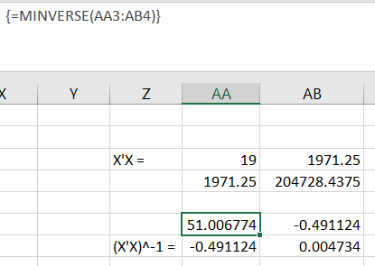
${\left(X^{*'}X^{*}\right)}^{-1}=\left[\begin{matrix}51.0067774 & -0.491124 \\ -0.491124 & 0.004734\end{matrix}\right]$
$\hat{β}=\left[\begin{matrix}{\hat{β}}_{0} \\ {\hat{β}}^{*}\end{matrix}\right]={\left(X^{*'}X^{*}\right)}^{-1}\left(X^{*'}Y\right)$
$\hat{β}=\left[\begin{matrix}51.0067774 & -0.491124 \\ -0.491124 & 0.004734\end{matrix}\right]$ $\left[\begin{matrix}383.3 \\ 39172.225\end{matrix}\right]=\left[\begin{matrix}312.4663 \\ -2.81728\end{matrix}\right]$
$Y^{'}Y=9517.19$
$CF=\frac{{\left(41.5+33.7+27.7+21.7+19.9+15+12.2+4.3+19.3+6.4+37.6+18+26.3+9.9+25+14.1+15.2+15.9+19.6\right)}^{2}}{19}$
$CF=\frac{{\left(383.3\right)}^{2}}{19}$= $7732.57315789474$
SST = 9517.19 – 7732.5731 = 1784.6168
SSR $={\hat{β}}^{*'}X^{*'}Y-CF=\left[\begin{matrix}312.4663 & -2.81728\end{matrix}\right]\left[\begin{matrix}383.3 \\ 39172.225\end{matrix}\right]-7732.5731578$
SSR = 9409.2762 – 7732.5732 = 1676.703065
SSE = SST – SSR = 1784.6168 – 1676.7031 = 107.91378
${\hat{σ}}^{2}=MSE=\frac{SSE}{n-p}=\frac{107.91378}{19-2}=$6.347869
The question was to test $H_{0}:2β_{1}=2β_{2}=β_{3}$ versus $H_{1}:At least one β_{i}≠0$ for $i=0,1,2,3$
The statistic test to use is Fisher F = $\frac{MSR}{MSE}=\frac{\frac{1676.7031 }{1}}{6.347869}=$ 264.14
Rejection region: Reject the null hypothesis $H_{0}$ if $F>F_{α,p-1,n-p}$
Where, the critical value $F_{α,p-1,n-p}=F_{0.05,1,17}=4.45$
Conclusion: Since the F-statistic is F = 264.14 > 4.45, the null hypothesis is rejected and at least one parameter $β_{i}$ is statistically significant.
  - 95% confidence interval for $β_{i}$ is ${\hat{β}}_{i}±t_{\frac{α}{2}, n-p}\sqrt{var\left({\hat{β}}_{i}\right)}$
- 95% confidence interval for $β_{0}$
${\hat{β}}_{0}±t_{\frac{α}{2}, n-p}\sqrt{var\left({\hat{β}}_{0}\right)}=331.7979±\left(2.131\right)\left(\sqrt{347.0164289 }\right)$
- $\left(292.0924, 371.5033\right)$
- 95% confidence interval for $β_{1}$
${\hat{β}}_{1}±t_{\frac{α}{2}, n-p}\sqrt{var\left({\hat{β}}_{1}\right)}=-1.54439±\left(2.131\right)\left(\sqrt{0.009740236 }\right)$
- $\left(-1.7547, -1.3340\right)$
- 95% confidence interval for $β_{2}$
${\hat{β}}_{2}±t_{\frac{α}{2}, n-p}\sqrt{var\left({\hat{β}}_{2}\right)}=-1.42191±\left(2.131\right)\left(\sqrt{0.021650185 }\right)$
- $\left(-1.7355, -1.1083\right)$
- 95% confidence interval for $β_{3}$
${\hat{β}}_{3}±t_{\frac{α}{2}, n-p}\sqrt{var\left({\hat{β}}_{3}\right)}=-2.24157±\left(2.131\right)\left(\sqrt{0.114683606 }\right)$
- $\left(-2.9634, -1.5198\right)$
Conclusion: 95% confidence intervals of all the parameters don’t include zero, thus all these parameters are statistically significant at 5% level of significance.

  - 95% joint confidence region for ${\hat{β}}_{2}$ and ${\hat{β}}_{3}$. What is your conclusion?
95% joint confidence region for the parameters associated with x₂ and x₃ can be constructed using ${\left(\hat{β}-β\right)}^{T}X^{T}X\left(\hat{β}-β\right)≤p x F_{0.05,\left(2,15\right)}$; where $β=\left[\begin{matrix}{\hat{β}}_{2} \\ {\hat{β}}_{3}\end{matrix}\right]$
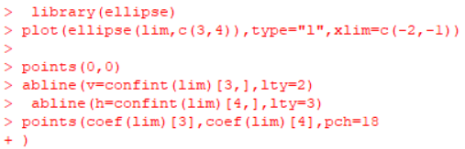
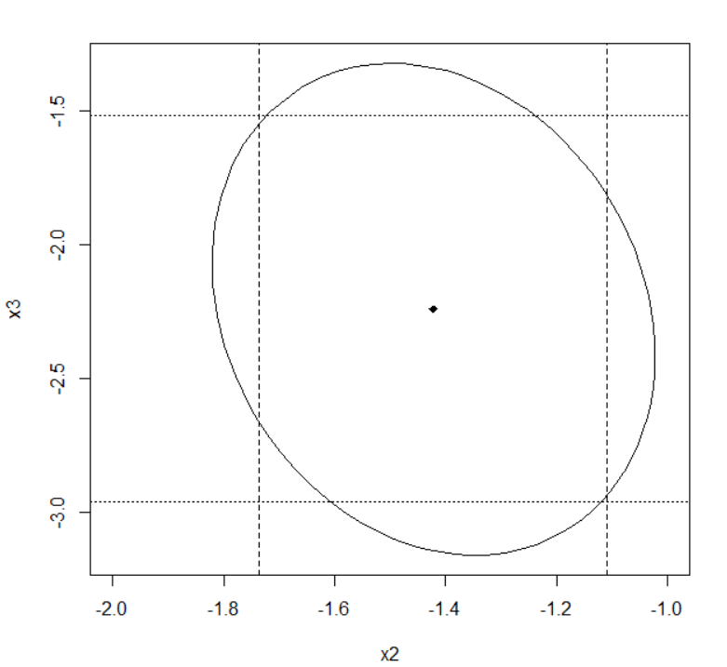
The location of the origin on the display in Figure above tests the joint hypothesis $H_{0}:β_{2}=β_{3}=0$
The joint hypothesis $H_{0}:β_{2}=β_{3}=0$ is rejected because the origin doesn’t lie inside the
ellipse.

