- (i) Plot the time series, ACF and PACF.
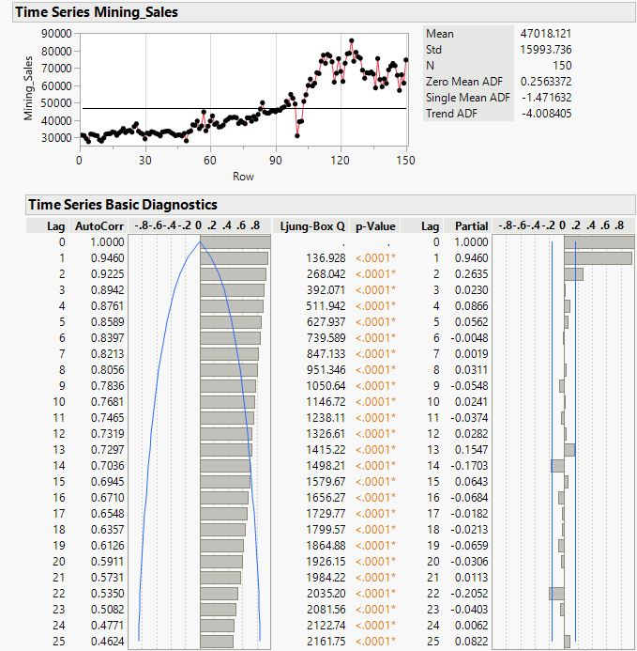
- Comment on the stationarity of the series.
The series is clearly trending upward. The PACF plot ends at lag 2, while the ACF plot exhibits a gradual decline. The observations 100, 101, and 102 demonstrate how the COVID-19 lockdown has significantly decreased production and sales, and how most activities and enterprises have shut down during this time. The series is not stationary, it is concluded.

- Justify the necessity (or otherwise) of any transformation(s) to stationarise the series.
It is recommended to stationarise the series with a difference of order 1, given the upward, nearly linear trend.
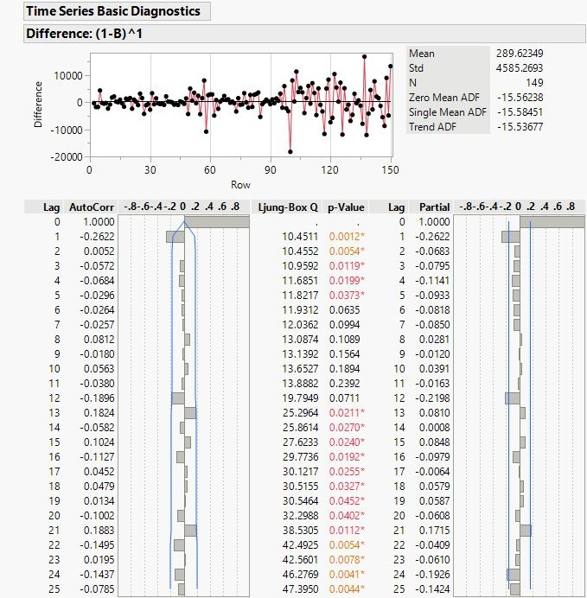
- Fit appropriate ARIMA model(s) to the series.
AS the differenced series’ ACF is outside at lag 2 and PACF is outside at lag 1, hence the appropriate ARIMA models will be of the parameters $p≤2$, $q≤1$ and $d=1$. Thus, ARIMA (2, 1, 1), ARIMA (1,1,1), IMA (1,1), ARI (2,1), ect… may be appropriate in fitting the series.
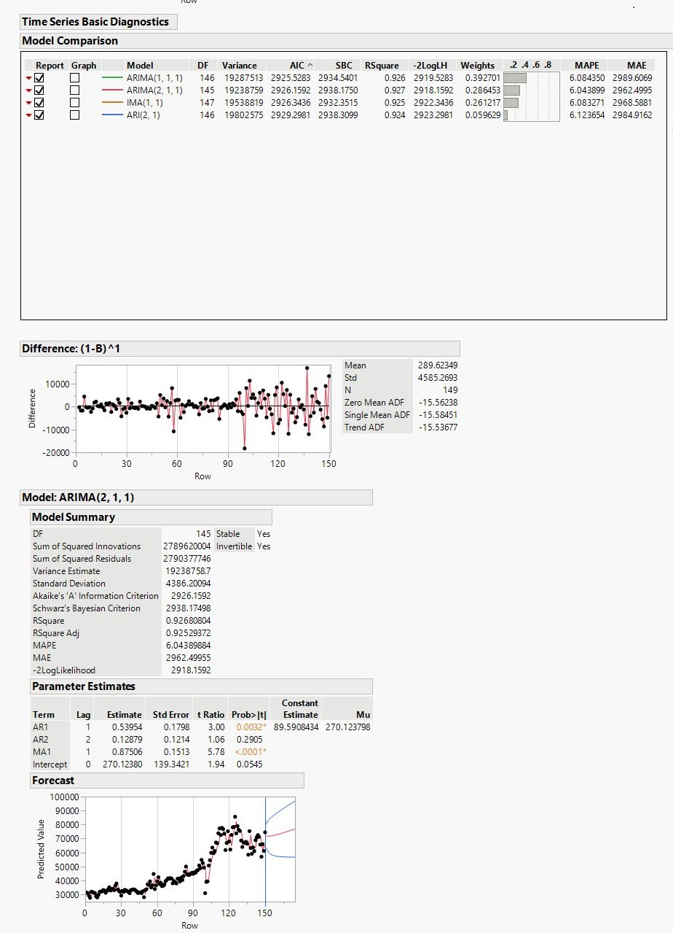
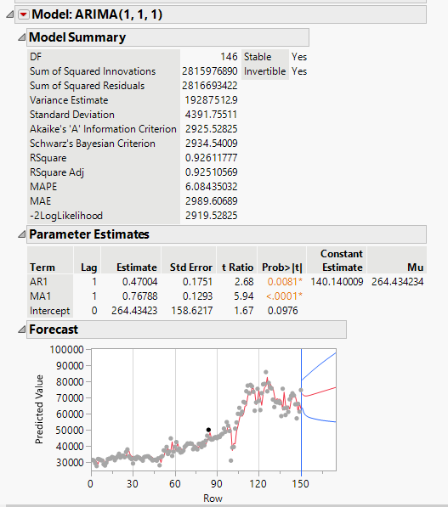
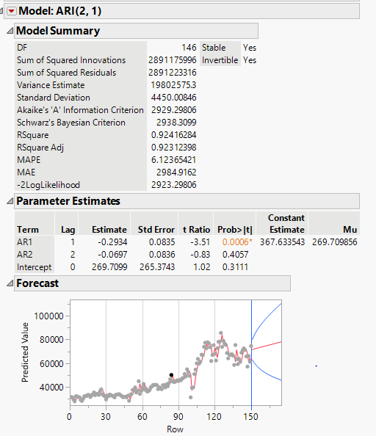
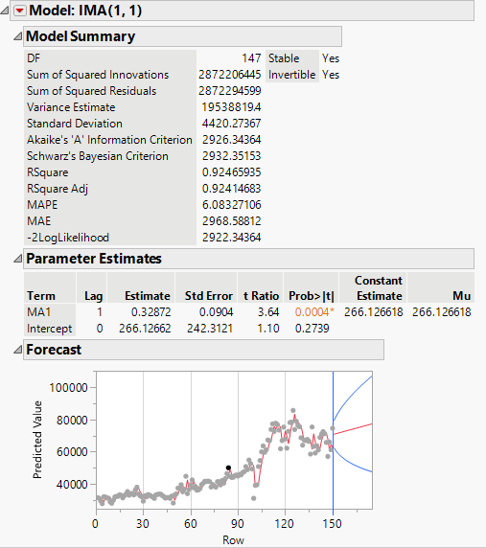
- Choose the best model and justify your choice.
Based on the lowest values of Variance AIC, MAPE, and MAE, ARIMA (1,1,1) is the best model. The software also indicates that ARIMA (1,1,1) is the best model and ranks first.
ARIMA model is ARIMA (1, 1, 1), where p = 1, d = 1 and q = 1.
- Write down the mathematical equation of the significant model chosen in (d).
ARIMA (1,1,1): $\left(I-B\right)Y_{t}=0.47004+e_{t}-0.76788e_{t-1}$
SE 0.1751 0.1293
P-value 0.0081 (< 0.0001)

- Use the chosen model in (d) to forecast the next two-year values for this series.

