THE BLACK DEATH

In the MIDDLE AGES (about 650 years ago) a terrible sickness spread across the world.

The black death, otherwise known as the bubonic _______________, is thought to have begun in ______________. It was carried along the SILK ROUTE all the way to Europe.

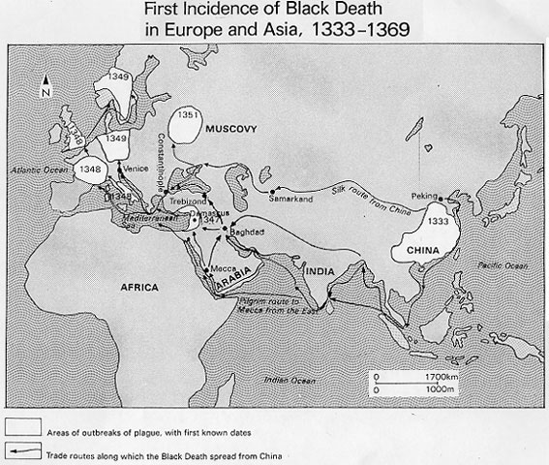

The plague was carried by _______________. The plague-carrying fleas travelled on the backs of RATS. These rats travelled in the carts which traders used to carry their _____________ to Europe, and in that way the plague spread very quickly from one country to ________________.

If you got bitten by a ________________ you could expect some very NASTY symptoms, then a very NASTY death. You would get fever, pain, and large swellings in gland areas. These swellings were called BUBOES, and were _______________ or _______________ in colour. That is why the bubonic plague is called the Black Death. The buboes were sometimes the size of tennis balls. If they burst, you MIGHT live, but most people ________________ very quickly. Most people died within 3 days.

Sneezing was also associated with the plague. We say “___________ ______” when people sneeze, because of its link to the biggest killing disease of the middle ages.

Over _______________ of the population of Europe died. Fields were left unharvested as there was nobody to gather in the food. Whole villages were wiped out and left deserted. Towns reduced in size. If you were rich, you MIGHT survive, if you could get to your country home and stay there away from everybody. But no-one was REALLY safe.

The Black Death occurred during the HUNDRED YEARS WAR between ________________ and ________________. The countries lost so many soldiers in the plague that they stopped fighting. They had a break from the war while they tried to get through the plague.

The plague reached England in cloth-carrying rats from _______________. Traders took the cloth to London and the plague spread. Soon it spread to every area of the country.

Doctors did not know the cause. They thought that maybe dogs and cats carried the disease, and many of these animals were killed. They also thought it might be carried by ‘bad air’, so people wore pouches (little bags) of flowers and herbs around their necks to try and keep the bad air away. Of course this didn’t work!
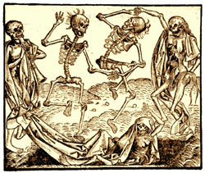
In towns and cities people lived very close together and they knew nothing about contagious diseases. The filth that littered streets gave rats the perfect environment to breed and increase their number. The disposal of bodies was also not done carefully. This helped to spread the disease still further as those who handled the dead bodies did not protect themselves in any way. They didn’t have rubber gloves or surgical masks! Men would come round with carts full of bodies, ringing bells and shouting “_______________________________________!”
Lack of medical knowledge meant that people tried anything to help them escape the disease. One of the more extreme was the FLAGELLANTS. These people wanted to show their love of God by whipping themselves, hoping that God would forgive them their sins and that they would not get _________________.

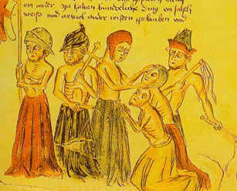

Flagellants hoping to escape the Black Death

The worst of the disease was over by 1351, but over the next centuries it occasionally surfaced (came up) again. The worst time was in 1665. It started in London but spread to other areas. __________________still had no idea how to stop it. People would draw __________________on their doors if someone inside the house had plague, as a WARNING to other people to keep away. The plague took 70,000 lives then, and only stopped when a great fire swept through London and killed most of the germs.
Different treatments
Vinegar and water treatment | If a person gets the disease, they must be put to bed. They should be washed with vinegar and rose water
Lancing the buboes | The swellings associated with the Black Death should be cut open to allow the disease to leave the body. A mixture of tree resin, roots of white lilies and dried human excrement should be applied to the places where the body has been cut open.
Bleeding | The disease must be in the blood. The veins leading to the heart should be cut open. This will allow the disease to leave the body. An ointment made of clay and violets should be applied to the place where the cuts have been made.
Diet | We should not eat food that goes off easily and smells badly such as meat, cheese and fish. Instead we should eat bread, fruit and vegetables
Sanitation | The streets should be cleaned of all human and animal waste. It should be taken by a cart to a field outside of the village and burnt. All bodies should be buried in deep pits outside of the village and their clothes should also be burnt.
Pestilence medicine | Roast the shells of newly laid eggs. Ground the roasted shells into a powder. Chop up the leaves and petals of marigold flowers. Put the egg shells and marigolds into a pot of good ale. Add treacle and warm over a fire. The patient should drink this mixture every morning and night.
Witchcraft | Place a live hen next to the swelling to draw out the pestilence from the body. To aid recovery you should drink a glass of your own urine twice a day.

ACTIVITIES

1. It is the year 1349. You live in the town of Colchester. The plague has arrived.

Write a letter to a friend in another town. In your letter include the following:
- warn them about the plague;
- tell them how they can recognize the plague (the symptoms); and
- give them your ideas about how they can stay safe.

2. You are a doctor and many people are asking you how to cure the plague. You decide to write a pamphlet describing your ideas for treatment. You can use any of the ideas in the table provided, or make up your own. Your pamphlet should be one page of A4 folded over. On the front put a title, such as:

‘How to cure the plague
by Dr D Debes’

