Work Collocations

Vocabulary Word | Definition | Sample Sentence
Internship | A temporary, low-level job to gain experience | She decided to take an internship at a marketing firm after graduating from college.
Entry-level job | A job that doesn’t require much skill or experience | He applied for an entry-level job in customer service at a tech company.
Minimum wage | The minimum salary required by law | Many teenagers start their first jobs earning minimum wage.
Team player | Someone who cooperates well with co-workers | Employers often look for candidates who are good team players.
Promotion | An increase in responsibility or position at work | After a year of hard work, she finally got a promotion to senior manager.
Raise | An increase in salary | He asked for a raise after successfully completing the big project.
Slack off | To get lazy or stop working hard | If you slack off at work, your boss might not trust you with important tasks.
Fired/Dismissed | To lose your job | She was fired for repeatedly coming to work late.
Heavy workload | A lot of work to complete | The team had a heavy workload to meet the deadline for the new product launch.
Overtime | Working extra hours | Employees are paid extra for working overtime during the holiday season.
Demanding job | An intense job with lots of responsibilities | Being a surgeon is a very demanding job that requires long hours.
Stressed out | Feeling very stressed | He was so stressed out from work that he decided to take a week off.
Quit your job | To leave your job voluntarily | She decided to quit her job and start her own business.
Competitive salary | A salary that is higher than average | The company offers a competitive salary to attract top talent.
Generous benefits | Extra benefits like health insurance, discounts, or a company car | The new job includes generous benefits like free gym membership and health insurance.
Career change | Switching to a different career or field of work | After 10 years as a teacher, he decided it was time for a career change.
Job ads | Advertisements for available jobs | She checked the job ads online every morning to find new opportunities.
Resume | A document summarizing one’s work experience and qualifications | Make sure your resume highlights your most relevant skills.
Cover letter | A letter sent with a resume explaining why the applicant is suitable for the job | He wrote a personalized cover letter for each job application.
Interview | A meeting where a candidate is asked questions to determine if they are suitable for a job | She prepared thoroughly for her job interview by practicing common questions.
Job description | Details about the responsibilities and requirements of a job | The job description clearly outlined the tasks and expectations for the role.
Job seeker | A person looking for a job | The career fair attracted hundreds of job seekers from across the city.
Menial job | A job requiring a very low level of skill | While saving money for college, she worked a menial job as a dishwasher.
Earn a living | To get enough money to survive | He worked two part-time jobs to earn a living and support his family.
Persistent | Not giving up | She remained persistent despite multiple rejections from employers.
Job offer | A formal proposal from an employer to hire someone | After the final interview, he received a job offer from the company.
Dream job | A job that would be perfect for you | Becoming a pilot has always been his dream job.

If you’ve just graduated from college and you’ve never had a job, you can start your career by doing an internship (a temporary, low-level job) to gain experience. Depending on the company, the internship could lead to an opportunity to get an entry-level job (a job that doesn’t require much skill or experience) at the same company.

Although you might be earning minimum wage (the minimum salary required by law), if you do excellent work and are a good team player (you cooperate well with your co-workers) you could get a promotion (get an increase in responsibility) or get a raise (get an increase in salary) – hopefully both! Just don’t slack off (get lazy), otherwise you’ll be fired/dismissed (lose your job).

It’s normal for there to be periods of time when you have a heavy workload (a lot of work) and need to work overtime (work extra hours). But if you have a very demanding job (an intense job with lots of responsibilities) and you’re stressed out all the time, then it might be time to quit your job (leave your job voluntarily) and look for another one.

Now that you have experience, you’ll be able to get a job with a more competitive salary and generous benefits (extra benefits like health insurance, discounts, a company car, etc). If you can’t find a well-paid and rewarding job in your field, it might be time for a career change.

The typical way of applying for a job is to read the job ads in the newspaper or online, then send your resume to the company with a cover letter. The company will then interview the candidates it feels are most qualified, based on the job description.

Sometimes job seekers need to take a menial job in order to earn a living while they’re between jobs. But if you’re persistent (don’t give up), a great job offer should come your way sooner or later – maybe even for your dream job (a job that would be perfect for you)!

Quiz: Complete the blanks in this conversation between two managers looking to hire a journalist:

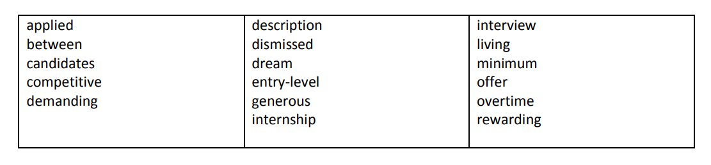
Melissa: Hi Terry, let's go over the list of people who have _____________ for the job.
Terry: Sure. There's Bob, who's fresh out of college and says this would be his "___________ job."
Melissa: Although I admire his enthusiasm, this isn't an _____________ job - we really need someone with a bit of experience.
Terry: Here's a resume from Dana - she's a freelance writer who's looking for a more stable way to earn a ____________. Unfortunately, she mentions in her cover letter that she's not willing to work _____________ because she has two small kids at home.
Melissa: Hmm... this is a rather _____________ job and sometimes we do need to work late. Let's not rule her out, though. Who else is in the running?
Terry: There's Steven, a veteran reporter who's currently ______________ jobs. He makes it clear in his cover letter that he expects a ______________ salary and ______________ benefits.
Melissa: He might be worth it. Why did he leave his last job?
Terry: Um, well, I checked his references and it turns out he was _____________ for sexual harassment of a co-worker.
Melissa: Oh... that's not ideal. Do we have any other __________________?
Terry: None who are particularly qualified - there's a marketing consultant looking for a ___________ change, and a few people who apparently didn't read the job _____________ and sent us generic letters.
Melissa: Maybe we could __________ Dana the job, and if it's too much work for her to handle, we could have Bob do an _______________ to help her out. We could only afford to pay him ____________ wage, but he might find the experience ______________.
Terry: OK – let’s ______________ both of them next week

Answer Key:
applied… dream…entry-level… living…between…candidates… competitive… demanding…. description… dismissed… … … generous… internship… interview…… minimum… offer… overtime…rewarding

