The Heart & Circulation of the Blood:

- Human CVS – blood flows in a circle, heart responsible for driving the blood flow, heart acts as a PUMP (two pumps but fused together)

  - Aristotle’s view
  - Central sense organ = Heart

  - Heart Disease
  - Fat deposits at base of a heart: hypertrophic cardiomyopathy
    - Heart difficult to pump the blood through body

  - Human heart
  - 1000s of electrically connected mononucleate cells joined end to end to form myocardial fibers

  - Papillary Heart Muscles: muscles that stretch across the chambers of the heart
    - Supporting heart valve function

  - Structural Anatomy of the CVS:
    - The heart appears as a single complex organ
    - The vessels carrying blood both away from the heart and back to the heart also appear complex/

    - Conventions:

      - Oxygen blood -> red
      - Carbon dioxide or oxygen poor blood -> blue
      - Arteries carry blood away from the heart
      - Veins carry blood back to the heart

      - Two distinct blood circulations:
        - The pulmonary circulation – associated only with the lungs
        - Systemic circulation – associated with all the rest of the body systems

  - Blood pressure:
    - Measured in mm Hg
    - Heart Contract and Relaxes
    - Human normal blood pressure: 120/80

  - Human Fetal Heart Development:

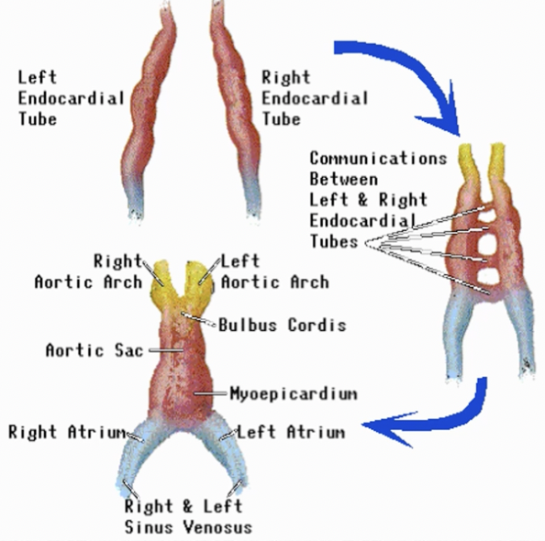

- Two separate pumps per one heart
  - Pump #1 receives oxygenated blood from the lungs then pumps it out to the rest of the body
    - Blood takes up oxygen and gives up carbon dioxide
  - Pump #2 receives deoxygenated blood from the body then pumps it out to the lungs
    - Blood gives up oxygen and takes up carbon dioxide

CVS – simple Model

- Two separate pumps per one heart
  - Pump #1 receives oxygenated blood from the lungs then pumps it out to the rest of the body
    - Blood takes up oxygen and gives up carbon dioxide
  - Pump #2 receives deoxygenated blood from the body then pumps it out to the lungs
    - Blood gives up oxygen and takes up carbon dioxide

