Critical Thinking Guide
COMPARE
Given Information
with
Prior Knowledge

LINK
Given Information
to
Prior Knowledge
to
What you want to find out.

How can link what I currently know and what I already know to determine what I am trying to find out?

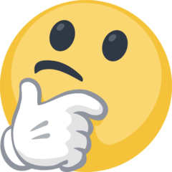
What am I trying to find out?
What do I currently know?

How does what I am trying to find out compare to what I already know?
ge can you use?

IDENTIFY
Given Information

